**USER GUIDE**

**for**

LandAdvisor

**A customizable ArcGIS Toolbox and framework for conservation assessment, planning, and management.**

*Documentation Version: Little Karoo 3.2.3 beta release*

July, 2013

***Contact information:***

John Gallo

@johnagallo

Email: [gallo.ja@gmail.com](mailto:gallo.ja@gmail.com)

And [john.gallo@consbio.org](mailto:john.gallo@consbio.org)

<http://landscapecollaborative.org>

<http://consbio.org>

707-962-9078

Table of Contents

Introduction 3

Toolbox Background 3

Where to go for Help, Support and to Log Suggestions and Ideas? 3

Modelbuilder 3

Document overview 4

Start-up guide 4

Quick Start-up using the Little Karoo data 4

More details (optional) 7

Notes about using different parameter values 8

Methods 10

• Multi-Criteria Framework 11

• Methods 12

Data and Guidance: 12

Geoprocessing Framework 13

LandAdvisor Little Karoo 16

A new approach for Connectivity: Linkage Location and Priority 17

A New Approach for Habitat Representation 18

Default Parameter Values 21

Other Components of Note 22

Open Science 23

• Results 24

Outputs 24

Habitat Representation 24

Connectivity 27

ROI and the Standard Run 27

Outputs 31

Customizing LandAdvisor for your Region 31

Set the Environment of your .mxd 31

Pre-processing your own Data for the analysis 34

Data Requirements and Starting-up using your data 36

License 40

GNU GENERAL PUBLIC LICENSE 41

TERMS AND CONDITIONS 42

References for all sections 42

Introduction

Toolbox Background

This toolbox implements a utility-maximization framework (Davis et al. 2006).  (Note: the hotlinks work if this document is in the support folder of the LandAdvisor directory.) This framework is based on the marginal value approach and return on investment principles that are increasingly prevalent in conservation science. These are discussed at length in the white paper in the support folder (Gallo & Lombard In Revision). The framework was first applied in a real-world case study in 2005 to create the [Regional Conservation Guide](http://www.conceptioncoast.org/projects_rcg.html) for the Conception Coast Project. The geoprocessing of this first application was performed manually. The second application was programmed using modelbuilder in order to make the effort more transparent and transferable. This second application occurred in the Little Karoo of South Africa in 2008, and provided decision support to a land trust and a government agency partnering to purchase and manage land for conservation (Gallo and Lombard unpublished) (A complete revision of that paper is in process). The third and fourth applications are underway, one by the Islands Trust Fund of Canada, and the other by the Sonoma County Agricultural and Open Space Preservation District. The modelbuilder toolbox that resulted from the second application has been improved further, bringing us to the present toolbox. Previous names of LandAdvisor that may be present in some documentation include Lorax, LandAdvisor, and LandAdvisor.

This version is released under the General Public License 3.0, with some additional stipulations. This means that the models and scripts are open access, and then improvements by anyone on the models, scripts, and framework are open access too. The details of this open source license are provided at the end of this document.

This version of the toolbox is compatible with ArcGIS 10.0 (ArcView or greater)and requires a Spatial Analyst license. Please see the [minimum specs](http://resources.arcgis.com/content/arcgisdesktop/10.0/arcgis-desktop-system-requirements) for a computer running ArcGIS 10.0

Where to go for Help, Support and to Log Suggestions and Ideas?

For help, the first step is to become familiar with the outline of this document.

Additionally, we have developed an online “collaboratory” (collaborative laboratory) designed to help with the application and further development of this model. It is there that you can download the model, data, the user guide, and then log support questions, interact with other people applying the model, use the project management tool called JIRA, and utilize many other collaborative tools.

The site is called [The Landscape Collaborative](http://landscapecollaborative.org) and embodies a broad mission “to inspire, empower, and assist people in sustaining our natural landscape. We are currently a budding community of scientists and practitioners sharing tools, knowledge and skills in implementing a [Landscape Decision Support Architecture](http://landscapecollaborative.org/display/WEB/Vision).” (Current November 2011)

Modelbuilder

Modelbuilder allows you to “program” models without knowing a command line programming language. You drag and drop commands/tools onto a blank “page”, and connect them with arrows. You can program iterations, loops, and feedbacks too. You can nest models within models, and link them together. There is also a good interface for documenting your work and providing a help file for your model. Please see the Working with Modelbuilder section of this document for more information.

Document overview

The Quick start Guide is for end-users wanting to run LandAdvisor on their machine using the Little Karoo data.

The table of contents is hotlinked to every section, and there is a link at the bottom of every page to return to the table of contents.

There are also hotlinks throughout the document, like this one to Pre-processing your own data for the analysis. You can use the back button in your pdf reader to return to where you were, and if viewing the word version, you can but the back button on your toolbar: .

One of the best ways to use this document is with the find function in your .pdf or .doc reader, i.e.: 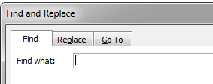

This is a living document, so please feel free to make edits/additions using tracked changes and comments to the MS Word version of this document (in your support folder). Send all comments/edits to John Gallo.

Start-up guide

Quick Start-up using the Little Karoo data

* Unzip the LandAdvisor zip folder into a location on your GIS harddrive
  + Note: It is best to put it in a location that is fairly close to the root folder. Some people have run into problems if they place it too deep in the directory structure. It is best but not mandatory to put this in a drive other than your C: drive.
* Open the LandAdvisor-LittleKaroo_vX .mxd in the unzipped hierarchy under …/LandAdvisor root folder. If there are several, use the one with the highest version number.
  + 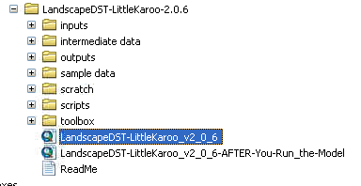
  + Note, if a screengrab shows LandscapeDST, that is the same as LandAdvisor
* Once opened, you should see a Toolbox called LandAdvisor-Little Karoo.
  + It should now be included on the long list of Favorite GIS Toolboxes that you are familiar with, such as “Cartography Tools”. Double click LandAdvisor to expand it. Example:
  + 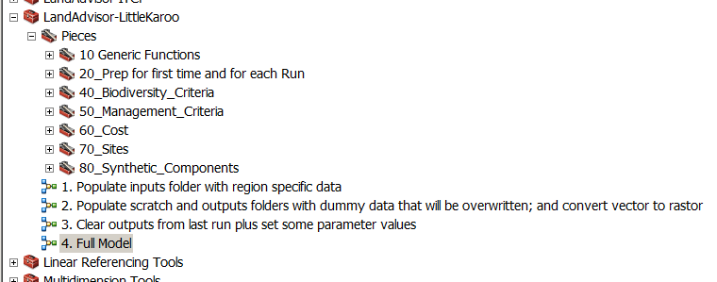
  + On some machine configurations, the toolbox opens up with some red x’s.
  + 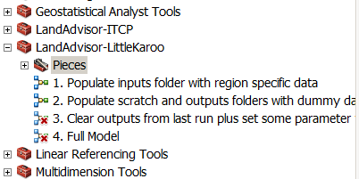
    - To remove these, expand the Pieces toolboxes, and dig deep to any models that have red X’s. “edit” them to view, then close them. It will ask if you want to save changes. Say yes. The red x shold disappear. We believe this has to do with finding the ArcGIS toolbox on your machine. There is a JIRA ticket logged to resolve this bug.
  + Run models 1-3 in order.
    - Run a model by double clicking it.
    - When a model says “This tool has no parameters” it is not an error. Just press OK. Example:
    - 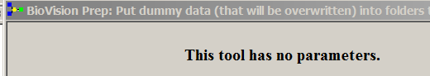
    - If it does have parameters, you can just use the default parameters.
  + Now run model “4. Full Model”
    - The Default settings for Version 2.1.0 are to keep running until enough properties are selected such that 25 Million Rand are spent towards acquisition, stewardship, and management actions over the next 30 years.
    - To change the default value of the model budget to be higher or lower, double click on the oval within the red circle below.
    - 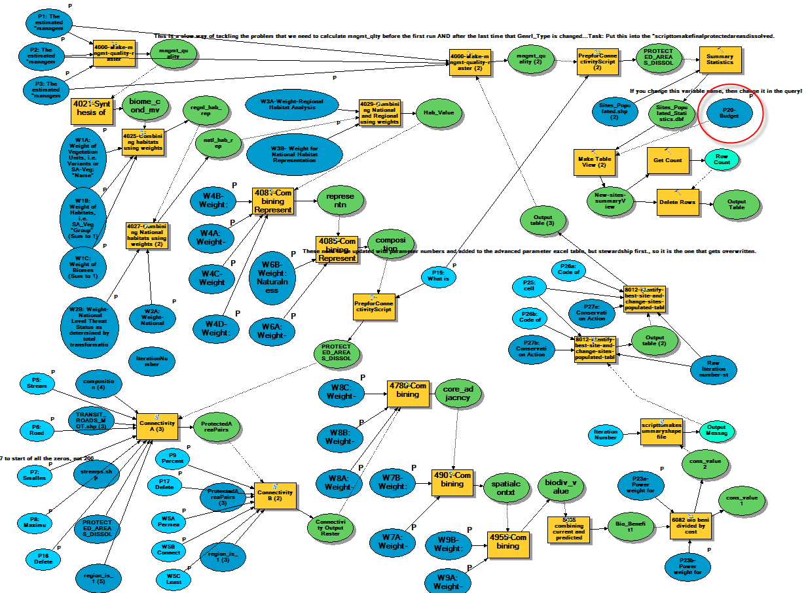
    - To make the model run a certain number of times rather than until the budget is met, right click on the above model, and select model properties/Iteration and click the top radio button and fill in the desired number of iterations.
    - 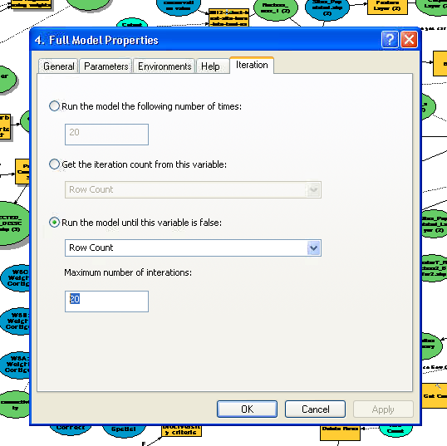
  + After Model 4 runs, you can add all or some of the layers in the outputs folder and examine the results.
    - * Click the add layers button, , and navigate to the outputs folder. (See tables for list of layers).
      * Tip: You can click the top one, hold down shift, and click the bottom one. This will highlight them all. Press add.
      * Tip: you can highlight them all in your mxd. Right click on one of them and press “Add to Group”. You can rename the group Outputs.
        + **Sites_Populated.shp** is the shapefile that summarizes all the important layers by planning unit (in this case, a planning unit is defined as contiguous property under the same ownership.)
        + The grids **cons_value1**, and **cons_value2** are the estimated value of conserving each hectare according to the acquisition strategy (1) or private stewardship strategy (2).
      * You can repeat the above for the inputs.

More details (optional)

* The nutshell of each model:
  + “**1. Populate inputs folder with region specific data”** This model asks you which type of Sample Data from the Little Karoo you want to use. [As of June 2010, there are only high resolution (100 m) data for the entire region, but subregional datasets may be clipped soon.] The model then copies these data into the input data folder while changing the file names to the correct names.
  + **“2. Populate scratch and outputs folders with dummy data that will be overwritten; and convert vector to rastor.”** This model puts “dummy” grids into the scratchworkspace so that the overall LandAdvisor model can run. The LandAdvisor model is composed of many sub-models, each one with required inputs. These required inputs need to be pre-existing for the model to start. The dummy grids you make now will be overwritten with the true data before they are used.
  + “**3. Clear outputs from last run plus set some parameter values**” After you run the model once there will be some data in the scratch and outputs folder for that run. These need to be cleared out before the model can run correctly again. This model also sets some of the parameter values.
  + **4. Full Model** This is the juice. See the methods section below for details.
    - It may take a minute to open, because it has to check to be sure everything is in place first.
    - For Model 4 a long list of parameters will be provided. You can simply use the default parameters and press “OK”. For example:

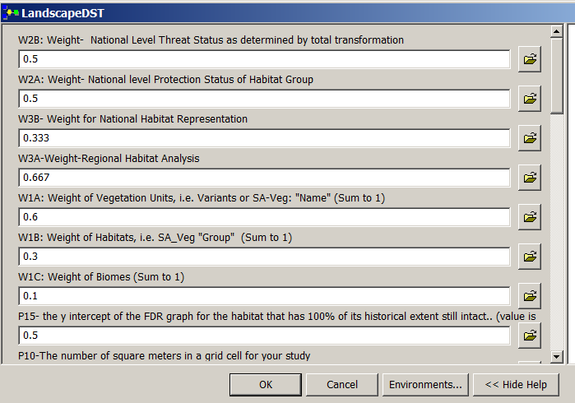

* + - It takes some time to load the parameter list and to change values.
    - **For definitions of the parameters, see the** **Method****s Section**
    - Eventually, the graphical user interface (GUI) where you change the weights and parameters will likely be a lot more user-friendly.
    - The screen grab below shows the final result for the default parameters from 14 June 2010 (they have since been modified slightly). In this case, The Relative Conservation Priority of implementing Action 1 (Acquisition and then Management in this case) is mapped, with no stretch of the color ramp.

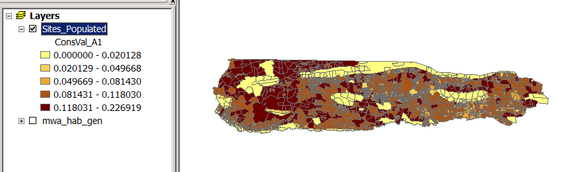

Notes about the model run

* Similarly, when the model is populating the shapefile, it gives a green error message in the details window. This is fine. It occurs when it gets to a null value.

Notes about using different parameter values

* If you would like to experiment with different parameter values, you can change them either by opening one of the above models and double clicking on the parameter and changing it; or, you can simply double click the model in the toolbox and change the parameter in the dialogue that loads. See the below chapter, especially the parameters look up table, for details about each parameter.
* To dramatically speed up the processing of the models 4 and 5, you can change some of the default parameters. For instance, changing P7 to 400 million will change the minimum size (in ha) of a core area considered for the connectivity analysis reducing the number of connectivity analyses significantly to about three. Secondly, you can reduce the budget from 25 Million to 10 million to decrease the number of iterations needed to meet the budget. See themethodsfor a table and descriptions of all the parameters.
* Do not be alarmed if it takes a lot of processing time to change any particular parameter value. That is one of the biggest drawbacks with the current modelbuilder interface. One of the top usability improvements in future iterations is to fix this annoyance, probably via calling a parameter table.
* If you are trying different parameter values, make sure you don’t overwrite your previous outputs by accident.
  + Note: This means that if you want to run the model once, and then again with different parameter values, *and you want to keep all the results from your first run*, then you need to copy the output folder from the first run and paste it somewhere else before running the model again.
* Tip: Messages in green are generally fine, including this one. It means that the budget has been met (As long as Row Count = 0), and the model will stop iterating…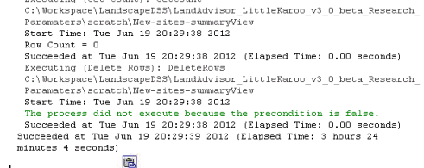
  + If you change the Budget parameter, then when model 4 completes you will need to assess it to see if it completed because the budget was met or the maximum number of iterations. In the Run Details Window, one of the lines near the end of the run window will read Row Count = 1 or Row Count = 0. If 0, then the budget was met, if 1, then the max number of iterations was met.
  + If Row Count = 1. Run model 4 again. Repeat your assessment of how it finished. (You’ll need to have the setting such that the run window stays open after the model completes). If you r computer can handle it, increase the max number of iterations in the model properties/Iterations dialogue.
  + If you set the Parameter for the budget very high, such that the computer needs to run for days to meet it, then it may run out of memory and crash. In this case, look in the outputs folder at a file like new_reserves to find out how many times it iterated before it crashed, and then set the max iterations a few iterations below that, as per the below:
    - * 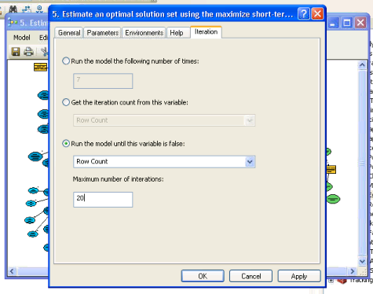
      * In this case. Close arc map, reopen, and run model 4 again. Repeat your assessment of how it finished. (You’ll need to have the setting such that the run window stays open after the model completes).
* Sometimes (in ArcMap 9.3), after changing the parameters and re-running, the model puts a lock on some of the files, and will give an error message sequence such as the below :

Executing (4849-Make-individual-Reserves (2)): 4849-Make-individual-Reserves2 %scratchworkspace%\Connectivity %scratchworkspace%\Connectivity\rsv0

Start Time: Thu Jun 30 16:11:40 2011

Running script 4849-Make-individual-Reserves2...

ERROR 999998: Unexpected Error.

Failed to execute (4849-Make-individual-Reserves (2)).

* The way to solve this particular error (often), is to close ArcMap (and Arc Catalogue to be on the safe side) and then re-open. It should work fine after that process.

Methods

EDITORS NOTE, July 2013. The following methods are pasted from a recent version of the journal article, in preparation. Some of these were then used as material for the new article, with a targeted publication date of 2014. An eventual iteration of this user guide can remove any redundancy. For the time being, there will be a minor amount of redundancy, or alternative text to escribe the same concept in both the article and the user guide. The methods that were here originally, and may be referred to in the below, are in the support folder title Old Methods. Multi-Objectiria is an outdated term that will be removed, and means a type of multiple criteria analysis that includes multiple objective, multiple attribute analyses.

* Multi-Criteria Framework

This approach was made possible because of a critical re-evaluation of how the principle of representation is pursued. A new analytical framework was devised that more accurately reflects the following assumptions about the principle of representation:

* the more a particular habitat type is conserved in a region, the better that is for biodiversity;
* as more of that habitat is conserved it becomes less important to conserve additional hectares of that habitat compared to other habitats in the region; and
* the *rate* at which this decline in importance occurs can be programmed to change depending on variables such as how much of the habitat has already been conserved (Davis et al. 2006).

The corresponding function of diminishing returns curve for each habitat can be simple (Figure 1), or more complex to match more ecological assumptions (see methods). The same principle can apply to the representation of species, or biophysical land facets.

Figure : A simple function of diminishing return (FDR) curve

Caption: None.

The implications of this approach is that the relative benefit of conserving any particular habitat at any particular time can be determined, regardless of if the amount of that habitat already conserved is over or under the conservation target determined in conventional conservation planning (e.g. Ball & Possingham 2000). The return on investment of conserving any particular planning unit can be estimated. Having detailed and clear prioritization information about each planning unit is especially important to land-use planners (Knight et al. 2006). This estimate is made by dividing the relative benefits of conserving the habitat types present by cost (the measures of which are introduced below).

To be clear, there are many ways to provide planning unit specific conservation information to planners. There are by-products of traditional conservation planning that are used to indirectly infer the value of a planning unit, such as the frequency index of the MARXAN software (Noss et al. 2002), or irreplaceability index of C-Plan (Cowling et al. 2003). Natureserve Vista is an example of a planning unit-specific conservation valuation system that does not address representation complementarity but has a very helpful graphical user interface and handling of natural heritage data (Stein 2007). The collaboration between the developers of Vista and MARXAN to allow the outputs of one system to be the inputs into the other is a promising step. Further, Marxan with Zones (Watts et al. 2009) is another approach, based on traditional conservation planning, for planning for multiple objectives.

One of the drivers of Multi-objecteria ROI development is that the challenge of achieving the triple bottom line can no longer rely on the reserve strategy alone. It will require wise management of the working landscape—the areas managed for both biodiversity and some form of direct economic gain that is not solely recreation-based (Good citation?). The framework accounting allows for such areas to contribute towards the representation of a habitat, but just not as much on a per hectare basis as those areas focused on biodiversity management. Additionally, there are some areas in a region where a particular habitat type is of very high quality, and other areas where it is more degraded. This framework allows for representation of the high quality habitat to count more than representation of lower quality habitat.

The framework uses a maximize-short-term-gains heuristic to pursue maximal coverage optimality: solution sets of planning units that if conserved, would best improve the representation of all the habitats in the region given a certain budget. The heuristic first identifies the most cost-effective planning unit, which is then assumed to get conserved. The relative benefit of conserving each habitat is recalculated given this assumption, and the new cost effective unit is identified. This is repeated until the desired number of planning units or budgeted cost is met (Davis et al. 2006).

* Methods

Data and Guidance:

One of the authors implemented the framework (Davis et al. 2006) in the Santa Barbara region as a pilot study (Gallo 2007). The lessons learned and new methods from that pilot were passed on to a pilot study in the Little Karoo (19,350 km2) of the Cape Floristic Region in South Africa (Figure 3). South Africa was chosen because a synergy of factors had resulted in it being a leader in conservation planning for implementation (Balmford 2003). The data used to develop and illustrate the model and framework are from this pilot study. The model and framework were customized subsequently in two other regions, discussed below. The key findings and sub-models from these studies are infused into the version of the model and framework released here.

Figure : Little Karoo Study Area

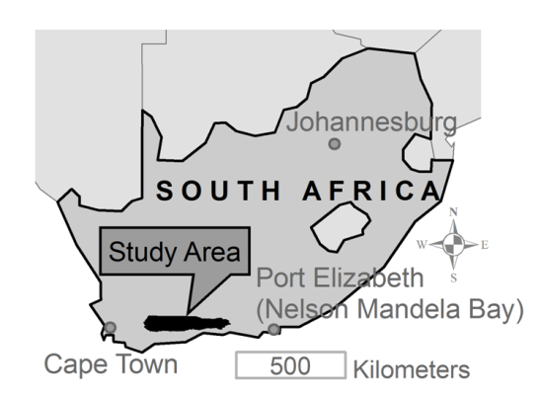

Caption: The second of four pilot regions used to develop this framework and model, and the source of the data used here.

Guidance and direction for the Little Karoo pilot was provided by assisting with the challenges of partnership between the Leslie Hill Succulent Karoo Trust (LHSKT) and CapeNature (CN). The LHSKT mandate was to purchase properties in order to conserve endemic succulents. The land was to be managed by a partner organization which, in this case, was CapeNature (CN), a government organization mandated with biodiversity conservation. CN also had a regional emphasis on consolidating conservation corridors identified in a previous SCP (Lombard et al. 2004). The CN budget available for management was extremely limited, so any additional lands provided by LHSKT were to also meet CN goals.

An initial two day scoping workshop was held in one of the existing reserves. Participants were four CN personnel from the study region, two LHSKT representatives, and three science advisors with extensive regional knowledge. One of the authors facilitated the workshops (JAG), and the other author was one of the three science advisors. The goals and timelines of both organizations were explicitly stated and documented, as well as the overall goal and expectations of the collaborative partnership. An initial list of criteria that could easily be programmed into the DSS was provided by the facilitator. In the spirit of collaborative design (Theobald et al. 2000), the participants then suggested additional criteria to include, the hierarchy for how all the criteria would inter-relate, and parameters that could be programmed into these criteria or the initial criteria. The participants also gave leads regarding data acquisition. Data were obtained and a version 1.0 of the DSS was created.

The data layers are detailed in the supplementary material (Metadata and Other Information) and are a nested vegetation map, species point locations, properties, habitat representation targets, transformation (i.e. degradation), roads, protected areas (including private conservation areas), cost of acquisition. Cost data were created based on expert consultation for the cost of managing an acquired property, the cost of putting a property into private conservation (stewardship agreement) and the cost of providing support and extension services to the private conservation areas.

A second, two day workshop was held to come to a consensus on the parameter values of the DSS and assess the resulting output. Some high level decision-makers from each organization joined the attendee list. There was a consensus that the conservation priorities provided by the DSS sufficiently met the objectives of each organization, and could be used as a proxy for formal board approval to begin inquiry with landowners and site visits. The improvements suggested during the workshop, and in the subsequent use of the DSS were used to guide further development. Subsequently, version 2.0 of the DSS was created to be more easily transferable to other regions and was released with the publicly available data from Little Karoo for illustration.

Two additional end-users, the Islands Trust in Canada and the Sonoma County Agricultural and Open Space Preservation District in California, customized version 2.0 to their regions using their data. Some of the insights and improvements of these efforts were added to the DSS, released here as version 3.1, along with the Little Karoo data (detailed in the supplementary material: metadata).

A disclaimer to the stakeholders and decision makers of the Little Karoo region is that the results presented here should not be used as decision support. Many parameters have been added since local involvement in version 1.0, and also the cost data were derived using a preliminary methodology with high uncertainty. To be used responsibly, the DSS should be re-parameterized locally and also use the more robust estimate cost data layer that has been recently developed.

Geoprocessing Framework

Platform

In the spirit of Open Science, the DSS is shared as an open-access ArcGIS Toolbox. It requires the ArcGIS (basic version) and Spatial Analyst licenses to run. It uses Modelbuilder sub-models to assist sharing. Modelbuilder allows the construction, documentation, and sharing of complex sequences of GIS commands (i.e. programs), including feedback loops and iterative analyses, all in a visual, drag-and-drop, menu-driven interface (ESRI 2008). Hence, it is understandable and programmable to a wider audience than command-line language programming, such as Python. However, some command sequences were not possible in ArcGIS 9.3 so there are a few Python scripts written into the DSS. We used ArcGIS 9.3 on a computer that had 3 GB of DDR2 RAM, an Intel Core-Duo 3.0 Ghz processor, and Windows XP operating system. The DSS is known to also run on ArcGIS 10.0. The DSS is available for download at [landscapecollaborative.org](http://landscapecollaborative.org/).

Spatial Units

The Multi-objecteria ROI framework can be implemented in either a vector or raster-based methodology. We chose the raster-based methodology because we predict it will be more compatible with an Open Science paradigm in the future in which a loose-knit group of collaborators are providing new criteria over time. It also seems more intuitive for new collaborators to participate in agile development by performing map algebra on the GIS layers rather than tables. The primary drawback is that it takes more computer processing time, but the assumption is that with Moore’s Law of technological development, this will be less of a factor over time.

Hence, the “cell” is the fundamental unit of analysis, and is a standard size for all raster grids. In the case of the Little Karoo, a cell was 100 m X 100 M (1 ha), which was the resolution of the vegetation layer. Vector layers were converted to 1 ha raster, and raster layers were resampled to be 1 ha resolution, making sure that the cell boundaries of all layers perfectly overlap. Such down-sampling introduces a type of uncertainty that needs to be evaluated by the GIS Analyst and/or an advisory team. In the Little Karoo, the team deemed this uncertainty acceptable. A “planning unit” is the geographic unit for reporting results. In the case of the Little Karoo, a planning unit was defined as a property, which was mapped as all the cadastres (parcels) that were contiguous and owned by the same person/entity. The value of a planning unit for any particular criterion is defined here as the mean value of all the cells in a planning unit. This can be done for any type of value such as conservation value, habitat representation value, etc. The Little Karoo advisors suggested that value might also be a function of variance within the planning unit. For their DSS we provided this option, but have removed it from the more generic model released here pending further evaluation. The term “place” is used in later diagrams as a generic term for area, and could be a cell, a planning unit, or any other polygon.

ROI of each land allocation change for each planning unit

The framework dictates that the end-users determine the list of possible land allocation end-states that are under consideration (Step 7 in the modified Steinitz framework). The Little Karoo version considers two:

* Allocation 1: Acquisition. In this case the land is acquired (purchased) by a land trust and then donated to a government agency, who is then responsible for the proper stewardship of the land.
* Allocation 2: Private Stewardship. In this case the private landowner maintains ownership of the land and enters into an agreement to perform the proper stewardship of the land. Such agreements are often called easements or covenants, and often provide a tax incentive or other benefits to the landowner.

The framework uses data to estimate, for every planning unit, the cost of implementing each land allocation change. The net benefit (described below) of the change is divided by this cost to determine the cost effectiveness of the land allocation change for each planning unit. This analysis is performed for each type of land allocation under consideration (Figure 4).

The net benefit of each land allocation change at a place is the benefit, towards the triple bottom line, of the proposed land allocation minus the benefit of its predicted allocation. The predicted allocation is the expected land allocation of the place in a certain number of years if no intervention occurs. (The time horizon is set by the end-users.) Ideally, it is the result of Step 4 of the Steinitz framework (projected changes).

In the Little Karoo pilot, the end-users needed a product as soon as possible, and an agreement was made to only use pre-existing data. There were no projected change data or studies available, so the standard assumptions were made: *all* lands not conserved in any way in the present cannot be counted on to contribute towards the ecological aspect of the triple bottom line in the future. Similarly, lands with a positive management quality, such as private stewardship areas, were assumed to retain this quality in the time horizon of 30 years (the horizon used in calculating ongoing management costs). The Santa Barbara pilot study used a more robust treatment of threat that combined two types of urban outgrowth model outputs with outputs from oil, grazing, and agricultural expansion models (Gallo et al. 2005). It is possible to run the model with various scenarios of change and compare outputs.

The current DSS only examines the ecological aspects of the triple bottom line, but is designed for the other aspects to be added in future iterations of any adaptive planning cycle. The end-users assign a value between 0 and 1 for every major land-use and/or allocation type in the region, with 1 being the most ecologically beneficial, such as Federal Wilderness. This becomes the “management quality” layer referred to later as variable *m* and in the user guide. Performing this estimate is difficult, and impossible to do with precision, but is arguably better than the convention, which is to have binary system of protected and unprotected lands. Ecological benefit of a proposed allocation at a place is its ecological value multiplied by the management quality value of the allocation.

Figure : Upper levels of the Multi-objecteria ROI framework



Caption: None yet.

The heuristic for generating solution sets of planning units

The maximize-short-term-gains heuristic introduced earlier first identifies the most cost-effective site for Allocation Two, and then Allocation One. If these were to get implemented, then the cost effectiveness values of all the remaining planning units would change slightly. The DSS calculates these new values as if the allocations do occur, and selects the next two units. This iterative process continues until the total budget is reached (Figure 5). The result is an estimate of the near-optimal sets of planning units for change from their current condition to Allocation One and Two. The details of this can be customized for a region. For instance, Version 1.0 selected the single most cost-effective planning unit and allocation combination, before re-iterating. This was changed to the current rule however, as the model was nearly always selecting stewardship allocations, and there was a requirement to spend money on the acquisition allocation as well. With this current customization, if a single site is estimated to be the most cost-effective for both Allocation One and Two, then it is assigned to Allocation One.

Figure : Determining a solution set of properties for change to Allocation One (Acquisition) and Allocation Two (Private Stewardship)



LandAdvisor Little Karoo

Each regional implementation of the framework can have its own particular set of criteria used in determining net benefit and cost. It can also be an exact copy of another region, or somewhere in between. In the Little Karoo pilot, ecological value is a weighted sum between the ecological composition of a place and its spatial context (Figure 6). The composition value of a place is based on the representation value of the habitat types and species present and the naturalness (all defined below). The composition values of all the places on the landscape are also an input into the spatial context analysis. They are used for the connectivity analysis, which also uses road size and location. The assumption is that it is better to connect two core areas (defined later) with a corridor that has a high average composition value than one with a low average composition value. The contiguity analysis determines if the cell is part of the cadaster, property, or watershed that is directly adjacent to a protected area (Figure 6).

Figure : The weighted, multi-criteria diagram of biodiversity value for the Little Karoo application.



Caption: Weight IDs correspond to Table of Weights in the User Guide (Supplemental Material). The weights were determined by the expert-based process. (Consider putting the unpublished draft manuscript about the stakeholder process in the supplementary material).

Combination of Criteria (Normalization)

Multiple spatial criteria are combined using a weighted sum. Before the weighted sum, the raster layer of each criterion is normalized according to the following method. The minimum (min) and maximum (max) value of the raster are determined, and every value (x) is transformed according to the following equation: (x-min)/(max-min), yielding a raster with values ranging from 0 to 1. The multi-criteria framework is hierarchical, and the output layer of a multi-criteria analysis was normalized before being used in another analysis. In future versions it would be good to give the end-user the option of normalizing by planning units rather than cells. In other words, the model would first summarize the original criterion value for each planning unit (e.g. attain the mean cell value for the planning unit), and then normalize all of the resulting mean values.

A new approach for Connectivity: Linkage Location and Priority

(Note: Grey text is covered in the journal article.)

The principle of landscape connectivity is that large core reserves should be connected by linkages of decent habitat to facilitate gene flow and population movements (Soule & Terborgh 1999). In general, “corridors” are linkages that have been designed for one species (Beier et al. 2008). We use “connectivity value” and “linkage value” of a place synonymously. To estimate the connectivity value of every cell on the landscape, we adopted the “least-cost corridor” methodology (Beier et al. 2008; Gallo 2007; Hartley & Aplet 2001; Lombard & Church 1993; Singleton et al. 2001) and made improvements to allow prioritization among linkages and the automatic rather than manual analysis and synthesis of all feasible pairs or core reserves.

Determine the “core areas”, and make the cost surface (value road traffic and stream corridors)

The end users choose what management quality threshold should be used in identifying the core reserves to be connected. The model then identifies all of the core areas that are comprised of land above the chosen threshold value, and are greater than a certain size (another parameter). Core areas can eventually incorporate other factors such as mean naturalness and habitat quality (Beier et al. In Press) by utilizing the “composition” output of the model in helping define core areas. The end-users also assign impact values to the different road types in the region, giving multi-lane freeways a higher impact value than dirt roads. (See Metadata document for the road values used in the Little Karoo analysis). An experimental parameter (Parameter 5) has also been programmed that multiplies the stream channel cells of a cost surface by a value of 1/x, allowing a lower cost to stream channels, but is deactivated for the Little Karoo by using the value 1.

In this version of the model, the composition layer is the primary basis for the cost surface; cells that have a high composition value are assigned a low cost. This identifies linkages that connect a lot of high biodiversity value land together (Rouget et al. 2006). Because crossing a 25 m road is often more risky for an animal than crossing over 25 m of poor quality habitat, the roads layer is multiplied by a constant (Parameter 6) before it is combined with the composition layer to make the cost surface. (The value of the cell of the cost surface is the maximum value of that cell from either the new roads layer or the composition layer.) Eventually, other cost factors such as geographic barriers can be added.

Linkage Estimation

For each pair of core reserves, three derivatives of the least-cost corridor are created and combined in a weighted sum. A least cost corridor analysis is performed using this cost layer and the locations of any two core areas on the landscape. The raw product yields a connectivity value for every cell on the landscape, so the user defines what percentage of the best cells to keep (Parameter 9). A standard approach is to choose a threshold such that the narrowest corridor on the landscape is wide enough for the species and/or ecological processes being targeted (Beier et al. 2008). This is known as a Least Cost Corridor output if done for a species. The Least Cost Corridor output is divided by the total cost value of the corresponding Least Cost Path. This way, all cells on the least cost path get a value of 1, and those at the edge of the corridor get a value such as 1.1 or so (depending on the value of Parameter 9, mentioned earlier). These values are then inverted and normalized, such that the cells along the least cost path get a value of 1, and the cells at the outer edge of the corridor get a value just above 0. This product is termed the “Connectivity Envelope.”

One of the problems with Connectivity Envelopes is that it does not attempt to distinguish the relative value of linkages between different pairs of core areas. Some corridors may be forced to traverse much moderate and low quality habitat, while others traverse much more high quality habitat.

The Permeability Index addresses this problem, and is calculated as follows. The first step is to divide Least Cost Corridor by the length of the Least Cost Path, not the total value. Hence, linkages that traverse a high percentage of high quality habitats will have a low relative value for this processing output known as the impermeability layer (not the permeability layer). All of the impermeability cells that fall outside of the Connectivity Envelope are turned to a null value (which is essentially a 0 value). This is output is then normalized as follows. The above is performed for every feasible pair of cores on the landscape. The pair that produces the lowest impermeability value is selected, and that lowest value becomes the benchmark value (“overall min”). The highest impermeability value of any of the corridors is defined as “overall max.” The default normalization formula mentioned earlier is then used. “Overall min” becomes a 1 in this layer (as it is the most permeable point of the most permeable linkage), and all the values for all the other linkages are less than 1 and greater than or equal to 0.

A final assumption is that if two different linkages have the same maximum permeability value, but one is much shorter than the other, then the cells in the shorter linkage should get a higher relative connectivity value. The user has an option of allowing this assumption. To implement this assumption, all the cells in a given least cost corridor envelope are assigned the value of the corresponding least cost path length (measured in number of cells). To normalize, the pair of reserves that have the shortest least cost path are selected, and the number of cells on that path is tallied. That value becomes the benchmark value (“overall min”). The highest least cost path length of any of the corridors is defined as “overall max.” This yields the Least Cost Path Length layer.

In order to speed up the processing time, the end-user is allowed to specify the maximum allowable distance between two core areas to be analyzed (Parameter 8). The suggested approach is to visually assess the map of all the cores of the landscape, and to identify the largest distance between two cores that could be connected without going through another core. Setting this parameter can dramatically reduce processing time by avoiding processing between core areas that are on opposite sides of the region and that have several core areas between them.

The weighted sum between the Connectivity Envelope, the Permeability Index, and the Least Cost Path Length layers is performed for each pair of reserves. The outputs of all these analyses are overlaid on top of each other, and the maximum value of a cell among all the layers is selected for the output layer. This way, when corridors overlap on top of each other, the best value is displayed on the final connectivity map. As long as the weight for Least Cost Path Length is greater than 0, this step also automatically removes the values for pairs of cores that are within the maximum distance, but also have other cores between them. The final connectivity map is then normalized using the standard equation, such that the best value on the map is 1, and the lowest valued cell that is a part of the lowest valued corridor is 0.

# Simplified Algorithm

**Connectivity A:**

* Generate Cost Surface = Z * (X + Y), where
  + X = 1 - Composition
  + Y = Road Threat X Road Threat Multiplier for Roads (with NoData = 0)
  + Z = 1 / Stream Benefit Factor for Streams (with NoData = 1)
* Exclude small Protected Areas
* For each Protected Area
  + Generate separate raster
  + Calc Cost Distance with Backlinks
* Determine the Distance between each pair of Protected Areas, limiting pairs to those at least as close as the maxProtectedAreaSeparation

**Connectivity B:**

* For each unique pair of Protected Areas
  + Calc Least Cost Path (LCP)
  + Estimate LCP Length as LCP Cell Count (potential to improve this)
  + Calc Standardized Corridor as Corridor divided by LCP
  + Create Corridor Envelope by eliminating higher values from Standardized Corridor using percentageCorridorValuesToKeep
  + Extract Corridor cells only within Corridor Envelope
  + Calc Impermeability as EXtracted Corridor divided by LCP Length
  + In the process, prepare for normalization
    - Find minimum and maximum of all Impermeability rasters
    - Find minimum and maximum of all LCPLengths
* For each unique pair of Protected Areas
  + Invert/Normalize Impermeability based on overall min and max (A - permeability from the wildlife perspective is desirable)
  + Invert/Normalize Corridor Envelope (B - crucial corridors between core areas need to be considered, even if they have low permeability)
  + Invert/Normalize LCP Length based on overall min and max (C - shorter corridors are better than longer corridors of the same permeability)
  + Calc Pair Connectivity as Weighted Sum of A, B, C (default weights 0.7, 0.2, 0.1)
* Calc Overall Connectivity as Max of all Pair Connectivity rasters
* Normalize the output so the lowest valued cell of the lowest value corridor is 0

A New Approach for Habitat Representation

The principle of habitat representation is essentially that in order to preserve biodiversity, it is wise to preserve the different natural habitat types of a study area. An assumption is that the more a particular habitat type is conserved, the better it is for biodiversity. Because trade-offs are central challenge of land-use planning and management, designating resources to conserve one type of habitat means those resources are not spent on a different habitat type. So they all need to be considered in conjunction. The SDSS uses an emerging approach called functions of diminishing returns (FDR): simply put, as more of a particular habitat type is conserved the relative benefit to biodiversity of conserving the next hectare of the habitat type diminishes. The percentage of the habitat conserved at any given moment corresponds to a point on the FDR curve, thereby giving a quantitative measure of benefit. In the simple example of **Error! Reference source not found.** conserving a cell of habitat that has 20% of its extent protected has a relative benefit of 0.80, while conserving a cell of habitat that has 30% of its extent protected has a value of 0.7. The power of this approach comes from the ability to make the FDR curve nonlinear in order to reflect ecological and conservation principles (Davis et al. 2006). Figure 7 is an example of such a curve. The end-user sets the values of several key parameters which will then apply to every habitat’s FDR. Each habitat could have its own uniquely shaped FDR, or it may have the same shape as some or all of the other habitats.  ~~The relative benefit of protecting the next hectare of the habitat not only depends on the shape of the curve, but also on how much of the habitat has already been “conserved.”~~

Figure : An example FDR that is more complex and designed to better address ecological and planning nuances.

The “naturalness” of a cell is incorporated into this analysis by valuing pristine examples of a habitat type are more than degraded locations of the habitat. In the Santa Barbara example of the framework, a combination of many land use data layers, such as grazing, oil and gas development, roads, parcel size where used to create naturalness types, which were then valued between 0 and 1 by local experts. In the Little Karoo version presented here, two remote sensing analyses of “habitat transformation” where classified and valued by the local experts (see “metadata” supporting material).

Determining how much a habitat has been “conserved” is based on quality weighted area and original (i.e. historical) extent.

Given:

*i* = a cell on the landscape of *n* cells.

*x* = quality weighted percentage of original habitat extent that is “conserved”

*m* = management quality value of the cell (described earlier).

*c* = naturalness value of the cell (described above)

*d* = area of the cell

*h* = original extent of habitat, using the same units of area as *d*. If historical extents for all habitats are not possible to estimate, then the current extents can be used instead (and setting Parameter X to 1). Test cross reference, see equation **Error! Reference source not found.**.

Then:

 (1)

The assumption is the original extent of the habitat was in pristine condition.

The y-axis value, *y*, is the relative benefit of conserving the next cell of a particular habitat, and is determined as follows.

*r* = the percent of historical distribution of the habitat that is remaining on the landscape.

 (2)

This is represented as a decimal. If this cannot be estimated for all the habitats in the region (which should have a mean of 100% if using development categories too, which can then be removed) then this nuance can be ignored, and the value of 1 can be used for every habitat. Next,

*t* = the conservation target (i.e. goal) for the species in question (e.g. if we want to protect 30% of the oak woodlands of a region in reserves, then *t* = 0.3). This optional parameter can be determined by a variety of approaches, if not already determined, or simply set to 1 (not available). (If *t* = 1 for all habitats, then it is recommended that *s*, below, ≠ 1, and is 0.5 or lower.)

Next, the following parameters values, which currently apply to all habitat types in the region, are either revised by the end-user or are left as-is to use the default values (Table 1).

*s* = "minimum y-intercept"- the y intercept of the FDR curve for the habitat that has the highest percentage of its historical extent still intact.

*q* = "initial flatline" The x value to which the curve is flat, (expressed in values 0-1).

*o* = "initial downward slope factor" - the slope factor for the curve between x = q and x = t; (0 ≤ *o* < 1).

*u* = "impact of target"- this factor affects the amount that the curve drops vertically once the target is met, (expressed in values 0-1).

*f* = "Right side slope" - The scalar affecting the x-intercept of the CBF curve, acceptable values from 0-1, default is 1.

*g* = the number of GIS map units in a gridcell (for UTM projections, the map unit is a meter)

Then the following intermediate variables are derived:

 (3)

(This is the y-intercept of the FDR curve for the habitat in question.) Also,

 (4)

 (5)

Given all of the above, the *y* value of any habitat on the landscape is determined as follows, using indent notation:

If target, *t < q* , then:

If *x < q* then:

 (6)

Otherwise:

 (7)

Otherwise:

If *x < q* then:

 (8)

Otherwise:

If *x<t* then:

 (9)

Otherwise:

 (10)

For end-users, more details and description of this habitat representation technique (and a review of arc tangent) are in the body and appendix of the user guide (supplementary material). This analysis was performed on the Little Karoo habitat data using the XXX classification, which has a total of 19 habitat types for the region.

Default Parameter Values

Table : Parameters and Default Values for the Little Karoo version of LandAdvisor

|  |  |  |  |
| --- | --- | --- | --- |
| Parameter # | Parameter Name | Notes | Default Value |
| 1 | Mngmt Quality of Statutory Conservation Area | The estimated management quality of government protected "reserves". | 1 |
| 2 | Mngmt Quality of Mountain Catchment Area | The estimated management quality of multiple-use zones such as the Little Karoo "Mountain Catchment Areas" | 0.74 |
| 3 | Mngmt Quality of Private Conservation Area | The estimated "management quality" of easements and other privately-owned stewardship areas. | 0.15 |
| 5 | Stream Benefit Factor | In generating the connectivity cost surface, the stream cells are multiplied by 1/x. Not used in Little Karoo. | 1 |
| 6 | Road threat multiplier | The road layer (which has a max value of 1) is multiplied by this constant before contributing to the connectivity cost surface. | 20 |
| 7 | Smallest protected area | The minimum size required to make a core zone eligible for the connectivity analysis. In map units, which are meters in the Little Karoo. | 37 M |
| 8 | Max protected area separation | The maximum distance (in map units) between core zones that should be considered for the connectivity analysis. | 50 K |
| 9 | Percentage of corridor values to keep | The percentage of values from an individual lesat cost corridor analysis that are used to create the corridor envelope. | 4 |
| 10 | cell size | A technical detail. The number of mapping units per cell. The mapping unit for the Little Karoo GIS file is 1 m. | 10 K |
| 11 | FDR initial downward slope | Variable o (see text). Influences the steepness of the first downward sloping section of the FDR curve. | 0.8 |
| 12 | FDR initial flatline | Becomes variable q. This is multiplied by 0.01 to become q-the x value to which the FDR is flat. | 5 |
| 13 | FDR impact of target | Variable u. The relative amount that the FDR curve drops vertically once the target is met. The y value is u*v. | 0.3 |
| 14 | FDR x intercept | Variable f. Influencing the steepness of the FDR curve to the right of the target. | 1 |
| 15 | FDR y intercept | Variable s. Relates to how much the % of original extent that is remaining influences the result. | 0.75 |
| 16 | Delete temp datasets A | A GIS "housekeeping" parameter, model will delete the temporary datasets for the connectivity analysis A | no |
| 17 | Delete temp datasets B | A GIS "housekeeping" parameter, model will delete the temporary datasets for the connectivity analysis B | no |
| 19 | core management quality | The minimum level of management quality that can qualify as a core area that needs connecting. | 0.7 |
| 20 | budget | The number of Rand (7 Rand ~= $1) budgeted for all changes in land-use allocation (acquisition plus stewardship) | 100 M |
| 23a, 23b* | "power weight" of benefit/cost for Allocation One | Variable p. A way of essentially "downweighting" the influence of the cost data on the results. | 2 |

Caption: Further detail about many of the variables is provided in the article text. The “default values” were those chosen for the “Standard Run” of the model. *The value of 23a and 23b should always be the same in normal operations. M = million, and K = thousand.

Figure 8 illustrates the FDR curves for two hypothetical habitats using these default values.

Figure : The FDR curves for two manifestations of the default parameter values.

Caption: The black curve corresponds to a habitat that has 100% of its original extent remaining and a target of 16%. The red curve displays the curve for a habitat that has a target of 28% but only has 10% of its original extent remaining, hence it has a higher y intercept. Habitat would need to be restored in order to attain the target.

Other Components of Note

Contiguity

Conserving large, contiguous areas decreases habitat fragmentation and the problems it brings, such as edge-effects, and not being is not able to support the regulatory level of the food web, including large predators (Soule & Terborgh 1999). For the DSS, a precursory contiguity heuristic was used where all the cells within a planning unit that was adjacent to an existing conservation area were automatically coded with a contiguity value of 1 and all other cells were zero. This criterion was used in determining the cost of implementation, and arguably should have been used in determining biodiversity benefit, but was not in concern of to avoid double-counting the criterion.

Multi-scale Multi-level Habitat Representation

Land-use planning and management occurs by institutions at multiple scales and levels (Cash et al. 2006). For example, geographic scale is one level, and temporal scale is another level. The other levels are jurisdictional, institutional, management, and knowledge. The cell-based multi-criteria framework presents an opportunity to integrate these various perspectives. We performed an initial exploration of this opportunity by looking at habitat representation. The general approach could apply to other land-use criteria as well.

To summarize, a form of multi-temporal scale analysis was combined with a multi-geographic scale analysis to yield a multi-scale, multi-level analysis. The habitat data colleceted are nested such that any given cell is a vegetation unit type (N = XXX), a habitat type (N = XX), and a biome type (N = XX). Performing the habitat representation analysis on biome type is essentially a long, geologic timescale approach at the habitat representation principle. It is assuming that to preserve biodiversity, it is important that the four major biomes in the region should each have sufficient areas conserved for evolution to proceed. Meanwhile, performing the analysis on the vegetation unit is referencing a shorter timescale in choosing conservation priorities. The three analyses were combined in a weighted sum to get a single output for the regional scale. This was then combined in a weighted sum with a supra-regional analysis that considers a much larger reference region in determining percent of habitat conserved. This identifies priorities at the coarser geographic scale. Ideally, the supra-regional analysis uses the same methodology and data standards as the regional analysis. This was not possible in the Little Karoo study, and instead the national level priority habitats within the Little Karoo were from a previous study (CITE).

Species Representation

Functions of diminishing returns can be used for species as well. The minimum input requirement is a presence/absence map for every species in question. For the Little Karoo, the details are beyond the scope of this paper, but the summary is as follows. We assigned a standard classification system to database of 70,000 observations compiled from eight institutions (see Supplementary Material: Metadata and Other Information), and pared this down to 10,000 high quality observations of species of interest. For each species, a map was made in which each observation received the same accuracy value, which was then divided across the area (in cells) of the observation. Hence, an observation that was accurate to one hectare would have an accuracy value of 1 for that single hectare cell, but one that was accurate to 1 km2 had an accuracy value of 0.01 for the 100 cells. This was combined with management quality to get percent of current distribution protected. A simple FDR curve was used for each species (Figure X-Simple mv curve), with the slope and y-intercept dependent upon the listing status of the species (the most endangered species had the shallowest slope and highest y-intercept).

“Power-weighted” benefit/cost ratio

In all four pilot studies, and numerous others observed, the estimated cost for implementing the allocations on any panning unit had a very large uncertainty. End-users complained that this layer was having too much of an influence on the final results, and requested an option to include cost, but at a lower relative weight. Because benefit is an abstract function and cost was often in monetary terms, we applied the power factor to the numerator as follows:

*t* = net benefit of the allocation change for the cell

*r* = estimated cost of the allocation change

*p* = power factor (Parameter 23)

*k* = relative ROI of performing the Allocation in question

 (11)

Sensitivity Analysis of Key Assumptions

Running the model with the default set of parameter values (Table 1) is referred to as the Standard Run. The default values were determined at the local expert workshops, or, for parameters created post-workshop, based on the workshop and follow-up discussions. We also ran the model with a budget of 1 Rand to guarantee only one iteration, yielding the current, or starting value, every criterion. A sensitivity analysis was then performed by running the model many times, and each time making a single perturbation of one of the parameter values of the Standard Run. With X parameters and Y weights, it was beyond the scope to perturb every parameter multiple times. Instead, we perturbed parameters associated with large assumptions (Table XY-Values and Results of the Assumptions Sensitivity Analysis), and we perturbed them to values that were under discussion by the science advisors or stakeholders. It is essentially an analysis of the effects of key assumptions.  ~~For each assumption assessed, a reasonable value greater than the default was used, and then one less than the default.~~

One of the benefits of the flexibility of LandAdvisor is that it can be used to examine some of the long-standing assumptions and debates of conservation planning. In addition to the above, an exploratory run was performed in which several parameters were changed in the FDR curve. These were set in an attempt to perhaps more accurately reflect the intent of the Brundtland Commission (1987) and the IUCN (1992) than what occurred (see Discussion). All targets were set to 10%, the initial flatline was set to 10%, and the vertical influence of attaining the target was set to 0 (Figure 9). This is called the “IUCN-Pure” run. The “IUCN-Loss” run maintains the value of 0.75 for Parameter 15, to be slightly more consistent with the Standard Run.

Figure : Possible interpretations of the infamous statement of the IUCN Congress in 1992.

Caption: The grey line is how the IUCN statement was interpreted in most countries. The black line is arguably the intended FDR for all habitats, and is implemented here as the “IUCN-Pure” run. The black line is also the FDR for a habitat in the “IUCN-Loss” run that has been severely degraded. The red line is for the habitat in the “IUCN-Loss” run that is the most historically inact.

The relative influence of each assumption in changing the outcome of the model was estimated as follows. The output of each perturbation was evaluated for the percentage of planning units selected for Allocation One that were different than the units selected during the Standard Run (i.e. the output from using the default parameters). This was repeated for Allocation Two. These results were averaged to get a single estimate of the influence of the perturbation.

The relative certainty that a particular planning unit was a priority for an allocation change was estimated as follows. The outputs of all the perturbations and the Standard Run were evaluated, and the number of times that a planning unit was chosen for Allocation One was tallied, and likewise for Allocation Two.

Open Science

We are attempting to act in accordance to the new “open science” movement in the design, publishing, and further development of the Multi-objecteria ROI framework and LandAdvisor DSS. This movement posits that very nature in which we communicate as a society is undergoing a change as profound as when the printing press was invented, allowing the potential for mass collaboration on a scale never before possible (Tapscott & Williams 2008). For example, LINUX is a widely-used and highly successful computer operating system that was created outside of a corporate entity. The core code was released as open-source, and thousands of self-organized people worldwide are contributing to it in its ongoing development. The “open science” movement is the evolution of knowledge development, sharing, and science to better utilize the new internet paradigm towards grand problems such as addressing climate change and for pursuing the triple bottom line for a global network of regions (Nielsen 2011).

To facilitate model adaptation and growth, a collaborative scientific environment (collaboratory), has been created using the Atlassian web applications called Confluence (blog, wiki, discussion boards, etc.) and JIRA (task and project management, bug tracking, etc.). The entire model is available with an open-access license, along with all of the input and output data of the standard run, in a zip-file at this site ([www.landscapecollaborative.org](http://www.landscapecollaborative.org)). Running the model with the default values yields the results of this paper, and the end-user can modify the parameter values, or modify the model itself. The large file of output data from the sensitivity analyses will also be available on the site for at least 1 year, and then by request.

Sample Results

Outputs

Every run of the model produced a full suite of GIS layers that provide decision support. There is a raster layer for every box of Figure 4 and Figure 6. Further, there is a shapefile output that includes all the planning units of the region. Each row of the shapefile table corresponds to a planning unit, and there are dozens of columns, including the mean value of each raster layer (criterion) for that particular planning unit. This allows the end user to make maps of some or all of the planning units color coded by any criterion of interest. It also provides transparency to the user; they can see all the mean values of a particular planning unit to determine why it received such a surprisingly high (or low) ROI value for a particular allocation. These outputs and those of all the sensitivity analyses are too large to include as supplementary material so are available in a zip file on the collaboratory at landscapecollaborative.org. A sampling of the illustrative or notable results are mapped and presented here.

Unless otherwise programmed by the end-user, all of the values of the rasters and shapefile correspond to the last iteration of the maximize-short-term-gains heuristic. To obtain the current value for each cell or planning unit on the landscape at the time of analysis, the parameters should be set to run for only one iteration (e.g. Budget = 1).

Habitat Representation

The input layers and default parameter values of the Standard Run yielded the habitat representation values depicted in (Figure 10). These are for the first iteration of the model, before any planning units were selected in the heuristic. Habitats of highest representation value have low degrees of protection, low levels of average naturalness, and usually, but not necessarily, a high target.

Figure : Input data, parameter values, and outputs for habitat representation.

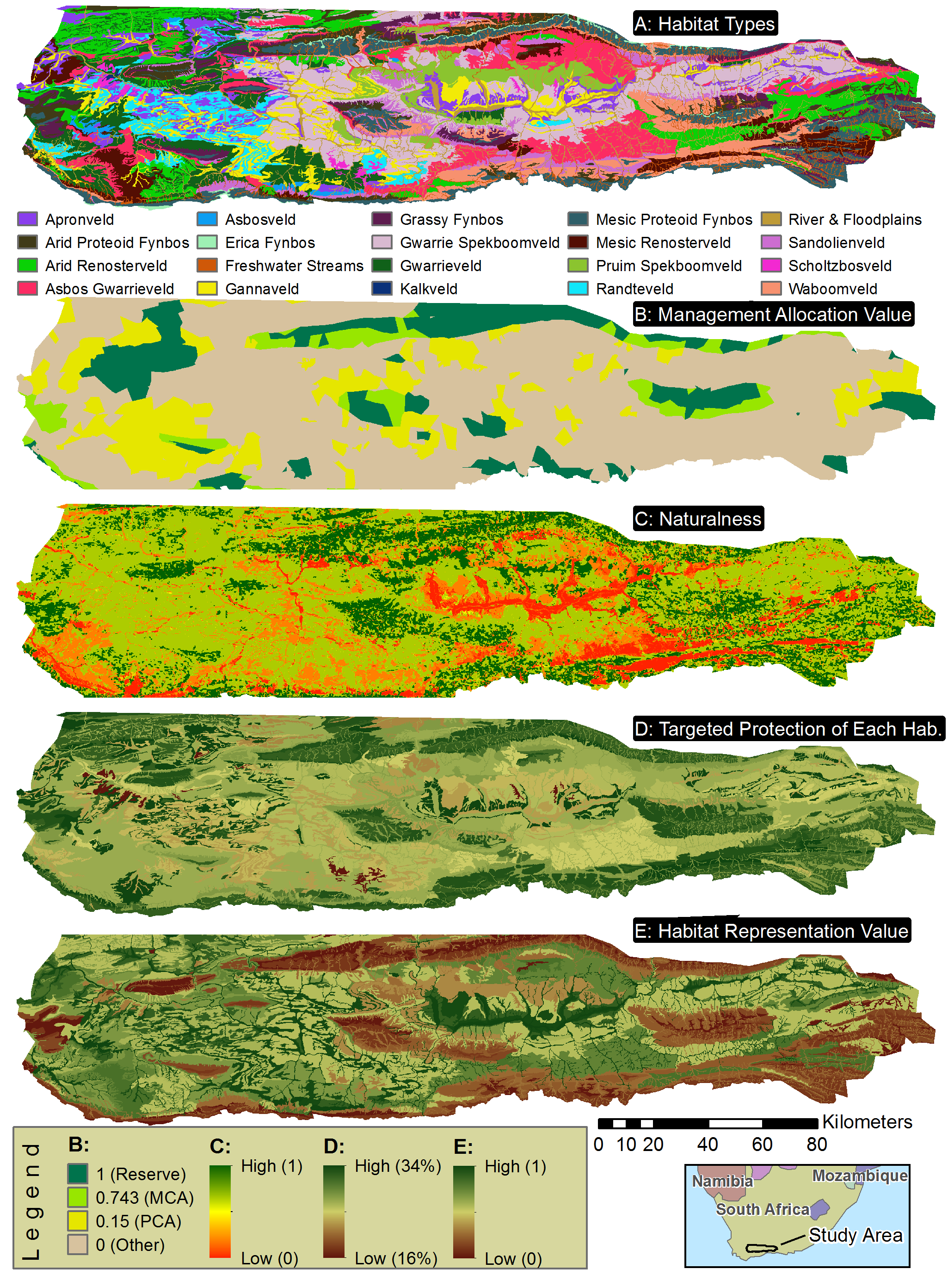

Connectivity

The connectivity analysis worked as we hoped, running automatically for the entire region, and indicating not only where the linkages were on the landscape, but also prioritizing among them (Figure 11).

Figure : Key input layers and output for the Connectivity Analysis

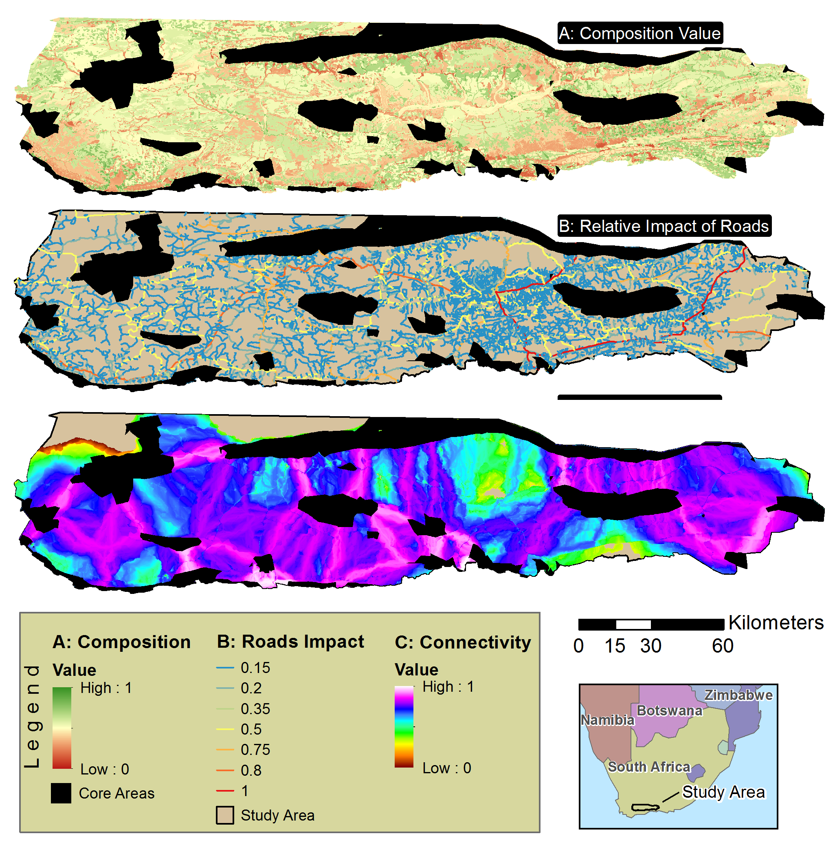

Caption: Note: The connectivity output displayed is for the first iteration of the heuristic.

ROI and the Standard Run

The ROI for converting a cell on the landscape either to a statutory conservation area (i.e. reserve) or to a conservation agreement with the private landowner is mapped (Figure 12). The mean value of these cells is determined for each property on the landscape to determine which one would be the most cost effective for the first iteration of the algorithm (Figure 5). This is implemented for each type of allocation, and the entire process is repeated until enough properties have been selected for each allocation such that the default budget is met. These two sets of properties are indicated with hashed lines on Figure 13A and Figure 13B.

Figure : Key inputs and intermediate products in determining the relative return on investment of changing management to Allocation One (Statutory Conservation Area) or Allocation Two (Private Stewardship).

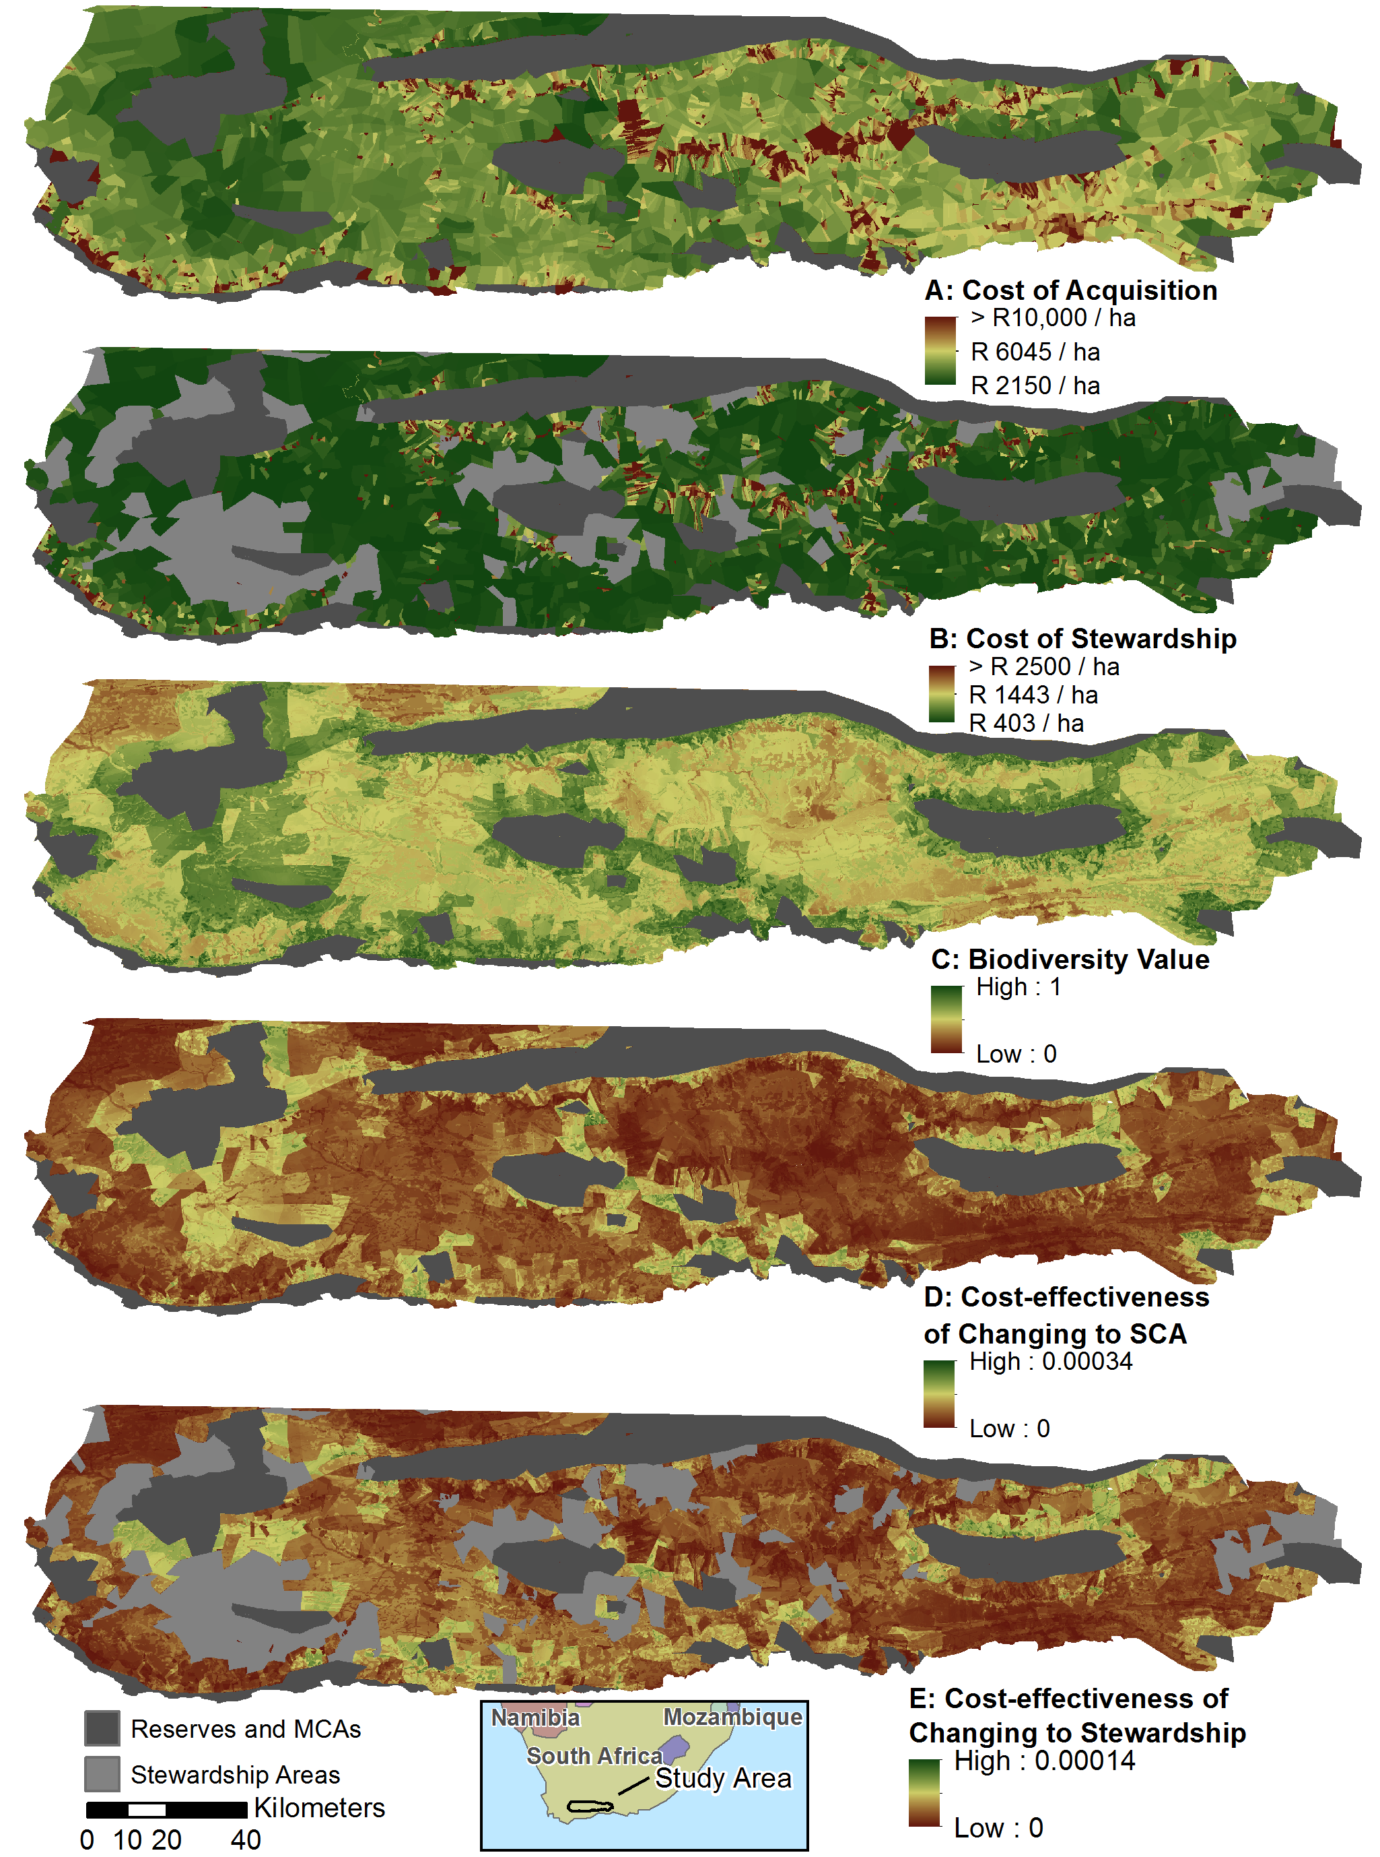

Caption: SCA = Statutory Conservation Area (i.e. Reserve). MCA = Mountain Catchment Area (i.e. Multiple-use Conservation Area) [Changes to figure: Change “Cost-effectiveness to ROI, or Relative Return on Investment]

Table 2 lists, in descending order, the estimated relative influence of several parameters in affecting the outcomes of the model. The relative influence is only an estimate as many of the criteria do not have a linear distribution of values, and the standard sensitivity approach of perturbing each parameter by some set percentage was not useful. For instance, Parameter 14 would yield the same result if the value is anywhere between 0 and 0.14, a second result for any value between x and 0.74, and a third result for any value between 0.74 and 1. Hence perturbing the default value of 0.7 by +/- 10% for instance, would yield no result for the lower range, and would not test the assumption targeted in the notes column of Table 2. For a study in which a wide variety of data were available regarding management quality, and hence, more than three management quality values on the landscape are used, then a systematic sensitivity analysis would be more appropriate. Fortunately, the creation of the criteria hierarchy and the choice of the default and perturbation parameter values both occurred well before the idea of using the sensitivity analysis to examine conservation planning assumptions. ~~Regardless, the conclusions about relative influence are essentially anecdotal at this point.~~

Table : Testing the Sensitivity of Assumptions

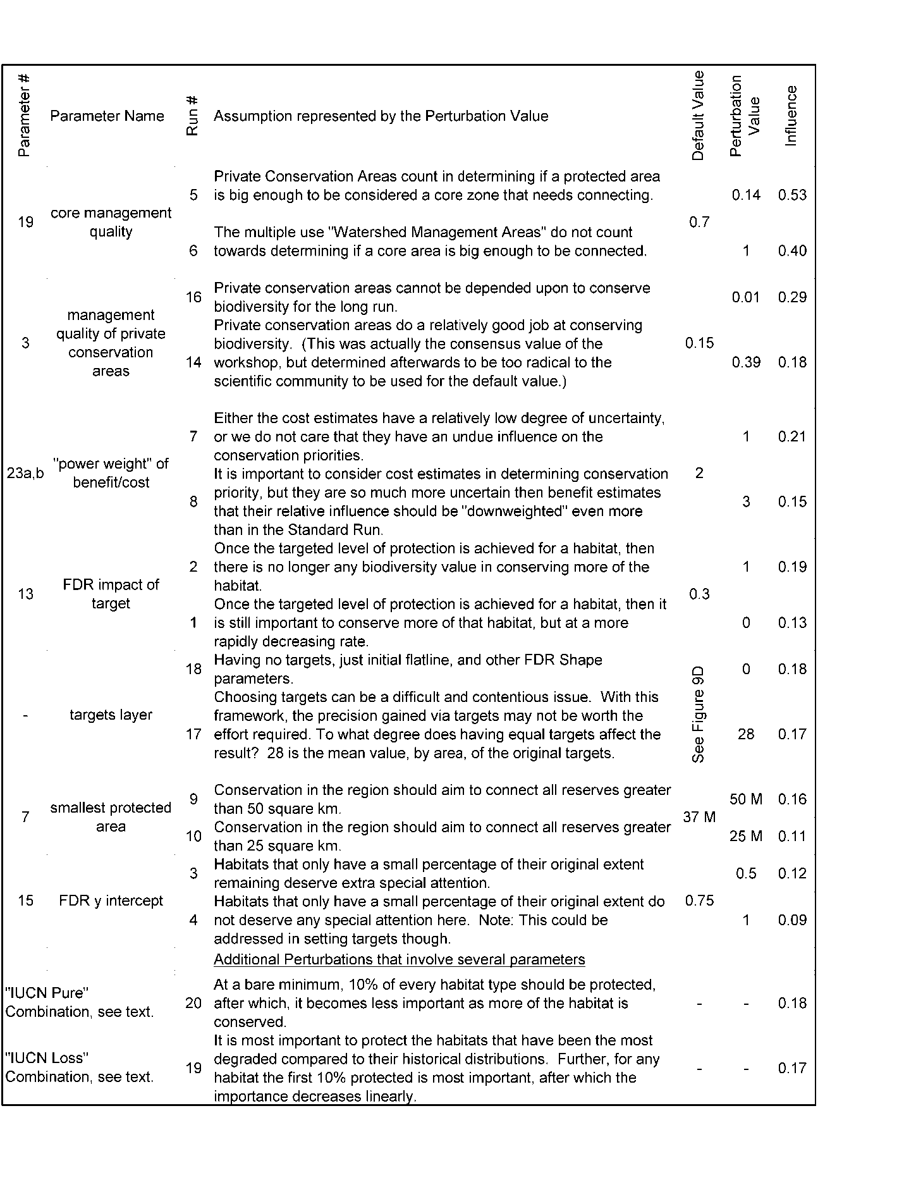

Caption: For each run of the sensitivity analysis, one of the default values (or sets of values) was substituted by one of the permutation values (or sets of values). FDR = function of diminishing returns. IUCN = International Union for the Conservation of Nature

Near the completion of the sensitivity analysis we realized that the initial downward slope factor (Parameter 11) needs to be less than one, as documented in this paper, not less than or equal to one as we originally assumed. If it is one, there are possible combinations of habitat distributions and parameter values that can result in a division by zero, which is undefined. We had the option of adding another if/then statement to the model formula and starting all over. But all work was being done slowly on periodic weekends, so we decided to instead alert the reader here, and to clarify this requirement in the documentation as well as the graphical user interface for parameterizing the model.

One of the characteristics of the emerging paradigm of open science is that it is increasingly acceptable to release science that is still rough around the edges in the name of increasing the velocity of knowledge (Nielsen 2011). To this end, and to further exploration and further development of the algorithm, we created an Excel graphing application called “Calibrating the Continuous Benefit Functions-Habitats.xlsx” (supplementary material) to complement the model. There are several worksheets organized by tabs. Using the Calibrator worksheet, the user can change the example parameter values to see how the FDR changes. They can see what happens to the curve when the initial downward slope factor is 1 instead of 0.999. In practice, the end user is encouraged to use this application in double checking the parameters they select.

There were two sites that were not selected in the Standard Run but were selected in nine of the 17 runs (Figure 13). All the other sites not selected in the Standard Run had a lower frequency. It appears from the figure that there are only three sites that are good choices for either Allocation One or Two, but that is a deceiving anomaly of the current algorithm. As mentioned in the methods, if, during one of the iterations for the maximize-short-term-gains heuristic, a single site is identified as being the most cost effective for both Allocation One and Allocation two, it is assigned to Allocation One. The accounting of this can be improved in a future version of the SDSS.

Figure : The Standard Run results and an indication of uncertainty regarding priority locations for implementing Allocation One (Acquisition and Management) and Allocation Two (Private Stewardship)

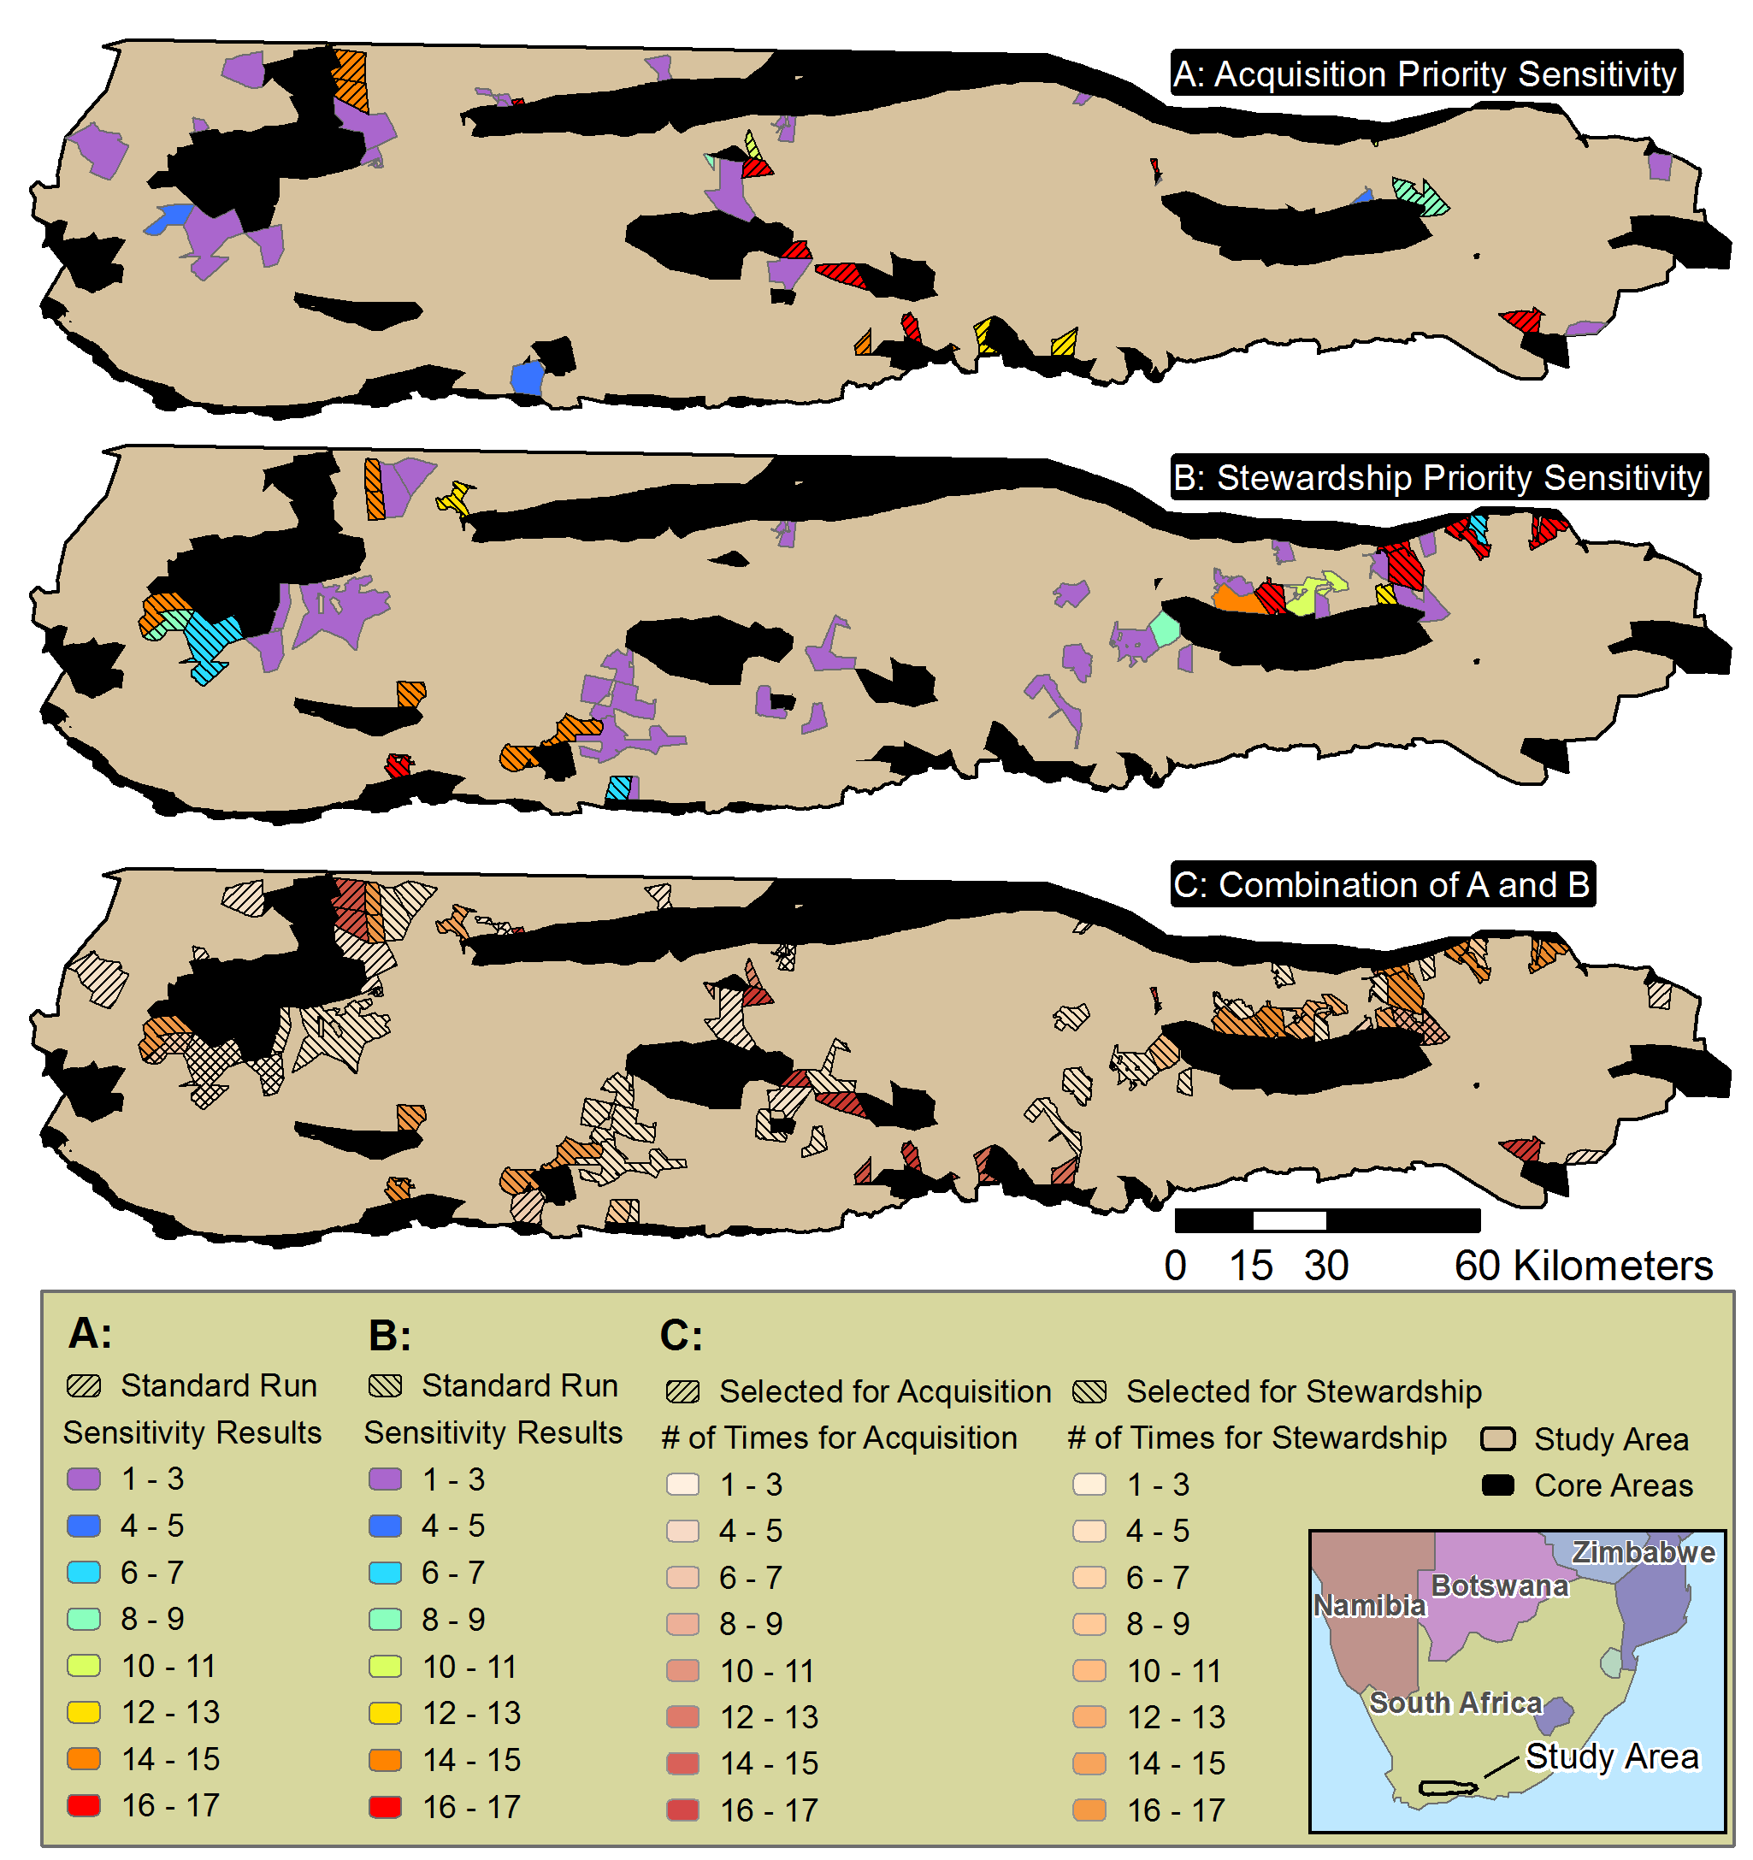

Outputs-(To be merged with above “sAmple REsults” section)

This section will be written at a later date.

For the time being, see the last bullet of the Quick Start Guide for a tip on displaying the results. Sites_Populated.shp is the most comprehensive and useful output. Each of the fields on the right side of the table refer to the key imput or output criteria, and provide the mean value of the cells of that crioteria for the planning unit in question. SequenceA1 are all the planning units selected for Conservation action 1, and SequenceA2 are all the planning units selected for conservation action 2. Use the find tool on this document for SequenceA1 for more information.

There is a draft table of all the outputs in the outputs folder. The table is called LandAdvisor_v3_x Outputs.xlsx and is in the Document Source Files folder within the support folder. Gives a quick indication of what each input file is for this version. It also indicates which of these may be obsolete and not necessary. Future versions will be in this document and will be cleaner.

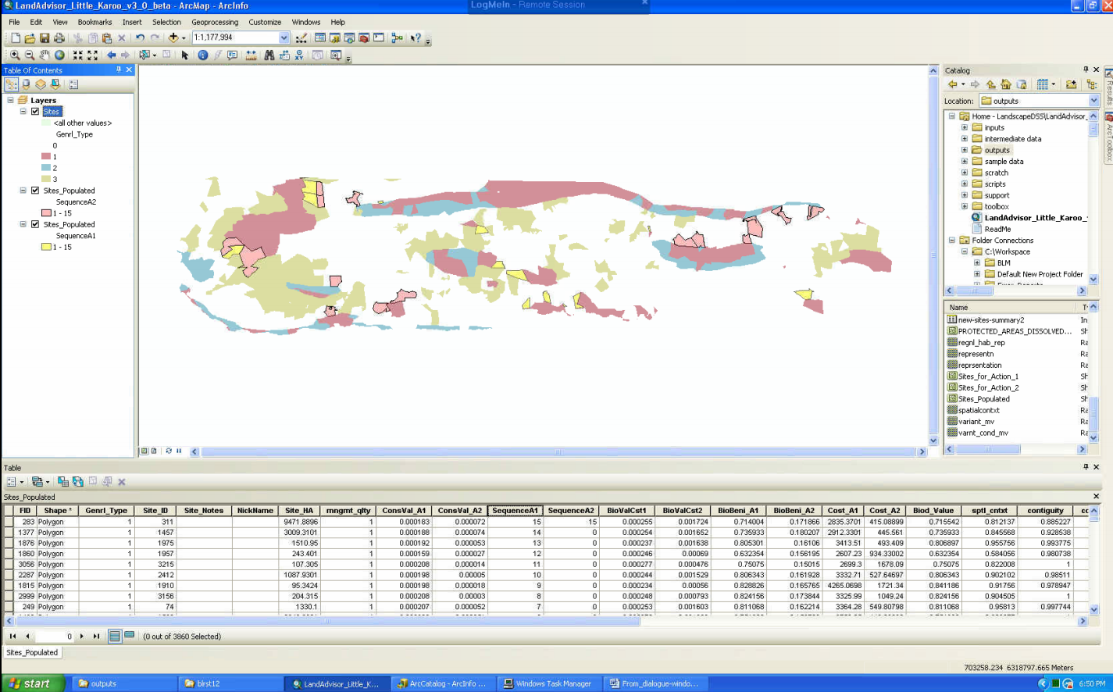

Customizing LandAdvisor for your Region

Note: please use the files (tables etc) mentioned at the beginning of the methods. Know also that there is a “tips and tricks for working with modelbuilder” section that also has some tutorials.

Set the Environment of your .mxd

If you want to make a new .mxd, make sure you implement the following steps.

* Make a new .mxd, then add any pre-existing toolboxes, or make a new one.
  + Right-click in the toolbox area and clicking “add toolbox” and then navigate to your toolbox, which should be in your LandAdvisor version X.X directory.
* click the box for “Overwrite the outputs of geoprocessing operations” such that there is a checkmark when you are done. (In 9.3. it was at In Tools/Options/Geoprocessing, in 10.0 it is in Geoprocessing/Geoprocessing Options)



* Set your workspace and scratchworkspace
  + ArcGIS 9.3 (If the model still works in 9.3?): In your .mxd go to Tools/Options/Geoprocessing/Environment/General and set them
  + 10.0: go to Geoprocessing/Environments/Workspace
  + Suggestions are that …/LandAdvisor/scratch is your scratchworkspace and that …/LandAdvisor/outputs is your workspace.

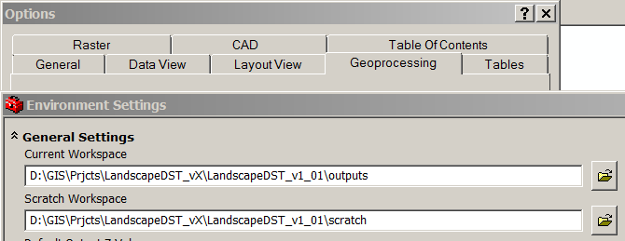

* Set your extents:
  + To be safe, set your output coordinates, based on a standard input layer.
  + Very important for making sure rasters align: set your processing extent and snap raster, based on a standard input layer. (region_is_0 is what is used in the sample analysis).

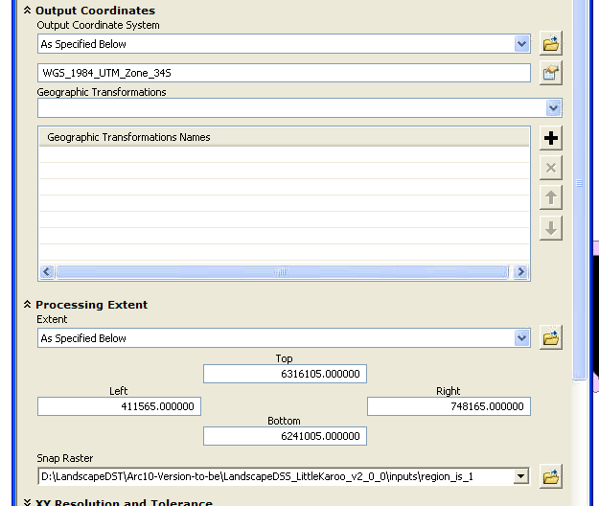

* + Set Raster Analysis to Maximum of inputs.
* The unit of analysis for the .mxd should already be set to a meter.
  + If you want to double check this: One way to do this is to use a coordinate system that has the meter as the default unit. For example, any of the UTM projections. You can check the system that your mxd is using by right clicking the word “Layers” and selecting properties, and going to the coordinate system tab.

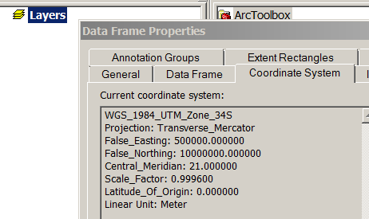

* Best Practice: It is important that we be able to leverage our collective resources. Hence, it would be great if any innovations you make can be shared with others. Often, land trusts and other partners have limited GIS budgets and only have the ArcView License of ArcGIS. Tools only available in ArcEditor or higher shuld be designated as such in their help overview. See also the compatibility [matrix](http://www.esri.com/library/brochures/pdfs/arcgis10-functionality-matrix.pdf) (using find).
* (Optional and suggested) Set your .mxd to “relative path” if it is not already.
  + This allows you to share your work with others if you make any changes to the model. It also makes it easy for you to move the LandAdvisor folder around on your harddrive.
  + To set this option, look under the File menu, click Document Properties, then click the Data Source Options button found on the lower right. This will open the Data Source Options dialog box, and you can specify whether to store absolute or relative paths.  
      
    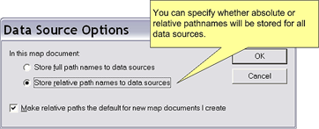
  + The functionality of relative path only occurs within the same root drive, it does not span data from the D: drive to the C: drive.

Pre-processing your own Data for the analysis

* Open a new .mxd and set its environment
* Set the projection
  + Import at least one of your input data layers. If this file has projection data set, this will set the projection of the .mxd
  + Any other time you import a layer that is not in that projection, press cancel. Do not let ArcMap adjust for the different projection. Every datalayer in your project should be the same projections. Over in Arc Catalogue copy it into the correct projection and then import the corrected file.
  + Double check that the projection is set correctly: Right click Layers/Properties/annotation Groups
    - The projection for LandAdvisor Little Karoo is WGS_1984_UTM_Zone_34S.
  + Set project extent.
    - This is especially important when you are creating raster files. If the extent is set, then they will all overlap perfectly, if not, then they will probably not all overlap.
      * To add: a screen grab of non-overlapping grids
    - To define your extent, first find out which one of your raw data input files has the largest geographic extent. It can be a shapefile or a raster. If a shapefile, convert it to raster with the finest resolution responsible for your data, and that your system can handle. (The sample data has about 2 million cells for the region of study). Right click the resulting raster and go to properties/source and scroll down to extent:
      * 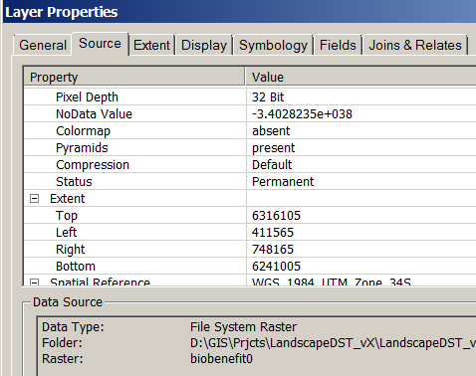
    - Write down the extent figures, and then set it into your environment: extent is partway down on Tools/options/geoprocessing/environments

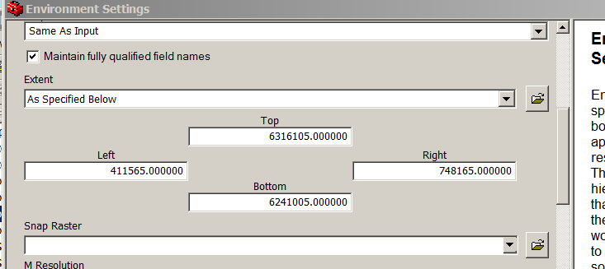

* Optional: Add your custom toolboxes
  + Open the toolboxes window while you are in ArcGIS ArcMap 9.X
    - i.e. click on the red toolbox icon 
  + Now, right-click in the toolbox window in some blank space, and select “Add Toolbox” from the menu that pops up.
  + Navigate to …/LandAdvisor/Toolboxes
    - Click on the “LandAdvisor” toolbox version that you want
    - Click Add
    - Also add the Toolbox named “Favorites_1”
  + (optional) Add a new toolbox, and call it LandAdvisor Pre-processing <your region name>
    - Add a model under that toolbox, and use this model to do your first pre-processing task. Examples include converting Core wildland areas shapefile into a grid of core areas, where all cores have a value of 1 and all else is no data.
* Decide where you are going to store you pre-processed input data that is ready for the model
  + See below section titled “Start up using Your Data”
* Populate that folder with all the data that you will need to run the sub-model or model of your choice.

Data Requirements and Starting-up using your data

* Put all the required data into the inputs folder. See Table 2 or for the most up to date see LandAdvisor v2.x Tables.xls for an indication of which data layers are needed as inputs (tab: Inputs). Most of the data layers that are not needed are indicated as such in the third column. “Pre-processed” or “need to finish” data are needed.

|  |  |  |  |  |  |  |  |  |  |  |  |  |  |  |  |  |  |  |  |  |  |  |  |  |  |  |  |  |  |  |  |  |  |  |  |  |  |  |  |  |  |  |  |  |  |  |  |  |  |  |  |  |
| --- | --- | --- | --- | --- | --- | --- | --- | --- | --- | --- | --- | --- | --- | --- | --- | --- | --- | --- | --- | --- | --- | --- | --- | --- | --- | --- | --- | --- | --- | --- | --- | --- | --- | --- | --- | --- | --- | --- | --- | --- | --- | --- | --- | --- | --- | --- | --- | --- | --- | --- | --- | --- |
| Table : Input Data; See the groups in the .mxd to determine which input data are required, suggested, unique to the Little Karoo, or derived.   |  |  | | --- | --- | | **GIS_Layer (raster unless .shp)** | **Description** | | biomes_g | A grid depicting the distribution of the major biomes in the region. This will be unneccesay for many regions in the world, as they only have one biome (also termed ecoregion). | | Cadastres.shp | Also knows as parcels. These polygons were used in the contiguity analysis to identify areas adjacent to already protected reserves. | | condition | The ecological condition (i.e. transformation and degradation) of an area. The amount of downweight is determined by the end-user using a Condition Benefit Scale. (Usually a pristine hectare gets a score of 1, and urban concrete a score of 0). Note: this was preprocessed for this version of the DSS, hence it is an input and an output. Eventually it will be parameterized as part of the model, and will be an output only. | | cost_mngmt1 | cost of buying the land, and managing it for X years (I think x = 30), cost is in 1000s of Rand per ha. (Original dataset was buy_n_mng_ha) | | cost_mngmt2 | cost of inspiring and overseeing stewardship of the land, and managing it for X years (I think x = 30), cost is in 1000s of Rand per ha. | | cost_mngmt3 | Not considered for sample data of version 1.01; therefore a filler dataset of 999999 or something like that was made. ( | | cost_mngmt4 | Not considered for sample data of version 1.01; therefore a filler dataset of 999999 or something like that was made. | | habitats_g | A grid depicting the distribution of all the habitats in the region. | | mgmt1efftvnss | The relative effectiveness of the management type 1 in protecting biodiversity. Can vary across the landscape. For instance, stewardship may be more effective in fynbos than succulent karoo. | | mgmt2efftvnss | The relative effectiveness of the management type 2 (also known as Conservation Action 2, see worksheet tab) in protecting biodiversity. Can vary across the landscape. For instance, stewardship may be more effective in fynbos than succulent karoo. | | mgmt3efftvnss | The relative effectiveness of the management type 3 (also known as Conservation Action 3, see worksheet tab) in protecting biodiversity. Can vary across the landscape. For instance, stewardship may be more effective in fynbos than succulent karoo. | | mgmt4efftvnss | The relative effectiveness of the management type 4 (also known as Conservation Action 4, see worksheet tab) in protecting biodiversity. Can vary across the landscape. For instance, stewardship may be more effective in fynbos than succulent karoo. | | ~~mngmt_quality~~ | ~~The relative effectiveness of the~~ **~~current~~** ~~management in protecting biodiversity. It is It is based on the duration/commitment of the management designation in place, as well as the quality of the management in preserving biodiversity. This is a prime layer for improvement in the Little Karoo, as it could have hundreds of differnt values, not just 4. Note: the layer was pre-processed, and is hence an input layer, but in future versions the populating of this layer should be part of the DST. It is included as an output field to help with cartography and context.~~ | | protweight | The degree to which one of the supra-regional habitat types is unprotected on a supra-regional scope. V1.01 note: This was done this way because South Africa had already done a national level GAP analysis, and had this value as one of its outputs (Rouget et al. 200X). See also transfweight. Other regions may have a very different set of inputs and weights for this supra-regional analysis. | | region_is_0 | Every cell in the region is = 0 (The pixel value for this raster must be signed integer. Floating point values can be converted using Spatial Analyst Tools -> Math -> Int) | | region_is_1 | Everycell in the region = 1 (The pixel value for this raster must be signed integer. Floating point values can be converted using Spatial Analyst Tools -> Math -> Int) | | Sites.shp | The shapefile that has the boundaries of all of the sites (planning units). A site was defined as all the cadastres (properties) that were adjacent and owned by the same person. | | species_mv | The combined marginal benefit of all the important species at a place. This depends on the status of each species, how much of its known extent is conserved, the CWA for that extent, and the precision of the observations. This was pre-processed for this Version. Normally it is an output only, not an input as well. | | targets_g | The conservation target (or threshold) for protection for each habitat type in the region (e.g. oak woodland +30%). The aspatial list was made spatial by joining to the habitats layer. | | TRANSIT_ROADS_MOT | The roads layer that gets burned into the cost surface that goes into the connectivity analysis. Needs a field called ROADS_THT that ranges has a max value of 1, and min value is >= 0. The highest traffic/speed roads in the region are a 1. | | transweight | The degree to which one of the supra-regional habitat types is transformed on a supra-regional context. V1.01 note: This was done this way because South Africa had already done a national level GAP analysis, and had this value as one of its outputs (Rouget et al. 200X). | | variants_g | A grid depicting the distribution of the specific habitat type variations in the region (N ≈ 250 or so). (In other words, there are several habitat variant polygons mapped within one larger habitat type polygon). These data are not always available. | | watersheds.shp | A shapefile of th watershed boundaries in the region. This is used in the contiguity analysis to identify areas adjacent to currently protected areas. | | streams.shp | A shapefile of the streams in your region. No specific field names are necessary, as the script creates the field that is used. (Or any shapefile, and set the P5: StreamsbenefitFactor parameter to 1) | |  |  |

* + There are three options for populating the inputs folder.
  + Option one (easiest) is to put all of your input data into a single folder or geodatabase on your harddrive, then to open the tool called **Data Prep: putting region-specific-data into the inputs folder** and to click on the folders icon of the parameter and browse to your data location.
  + Option two is to give each input data file the exact same name as the sample data names, and to paste them into the inputs folder.
  + Option three may be best in the long term, especially if you have a well established and stable datadirectory and workflow. This option is to copy, paste, and then edit the data prep tool: to open each input file location and point it to the appropriate location on your harddrive. This way, you can keep all the appropriate input files in separate folders in your data directory.
    - Note: you can also prepare for workshop settings by giving yourself the option of running the analysis with low resolution data. This gives you faster speed. To do this, first make the low res data files. Then can copy and paste this Data Prep model, rename it, and then change the filenames to match the low res data locations.

License

Terms and Conditions as of this version:

Following the lead of our friends in the field, the terms and conditions for using the Landscape Decision Support Toolbox are currently that:

1) **The rules of the** [**General Public License**](http://www.gnu.org/licenses/gpl.html) **version 3.0 apply to the software (i.e. the Toolbox). (Preamble is below)** If there are any portions of the GPL that we overlooked that are in conflict with the below conditions, then the below take precedence.

 2) You agree to acknowledge the intellectual property of the prior authors in all applications and dealings with this software.  Currently, you can cite the User Guide that is in the support folder.

3) If you publish some of the intellectual property located in the support folder, such as the Gallo and Lombard paper in revision, you either cite the paper or at the very least list John Gallo and Amanda Lombard in your acknowledgments section.  The draft is provided because time is short, we are losing species at an increasing rate, and we need to share our knowledge.

4) You agree to not share the password and/or zip file with with anyone, as it is important that every user sees the terms and conditions and registers.

5) You agree to inform the LDST coordinator (currently  john_gallo(at)tws(dot)org) of any publications or projects associated with this software. (We want to at least build a database of efforts using the framework.)

GNU GENERAL PUBLIC LICENSE

Version 3, 29 June 2007

Copyright © 2007 Free Software Foundation, Inc. <<http://fsf.org/>>

Everyone is permitted to copy and distribute verbatim copies of this license document, but changing it is not allowed.

Preamble

The GNU General Public License is a free, copyleft license for software and other kinds of works.

The licenses for most software and other practical works are designed to take away your freedom to share and change the works. By contrast, the GNU General Public License is intended to guarantee your freedom to share and change all versions of a program--to make sure it remains free software for all its users. We, the Free Software Foundation, use the GNU General Public License for most of our software; it applies also to any other work released this way by its authors. You can apply it to your programs, too.

When we speak of free software, we are referring to freedom, not price. Our General Public Licenses are designed to make sure that you have the freedom to distribute copies of free software (and charge for them if you wish), that you receive source code or can get it if you want it, that you can change the software or use pieces of it in new free programs, and that you know you can do these things.

To protect your rights, we need to prevent others from denying you these rights or asking you to surrender the rights. Therefore, you have certain responsibilities if you distribute copies of the software, or if you modify it: responsibilities to respect the freedom of others.

For example, if you distribute copies of such a program, whether gratis or for a fee, you must pass on to the recipients the same freedoms that you received. You must make sure that they, too, receive or can get the source code. And you must show them these terms so they know their rights.

Developers that use the GNU GPL protect your rights with two steps: (1) assert copyright on the software, and (2) offer you this License giving you legal permission to copy, distribute and/or modify it.

For the developers' and authors' protection, the GPL clearly explains that there is no warranty for this free software. For both users' and authors' sake, the GPL requires that modified versions be marked as changed, so that their problems will not be attributed erroneously to authors of previous versions.

Some devices are designed to deny users access to install or run modified versions of the software inside them, although the manufacturer can do so. This is fundamentally incompatible with the aim of protecting users' freedom to change the software. The systematic pattern of such abuse occurs in the area of products for individuals to use, which is precisely where it is most unacceptable. Therefore, we have designed this version of the GPL to prohibit the practice for those products. If such problems arise substantially in other domains, we stand ready to extend this provision to those domains in future versions of the GPL, as needed to protect the freedom of users.

Finally, every program is threatened constantly by software patents. States should not allow patents to restrict development and use of software on general-purpose computers, but in those that do, we wish to avoid the special danger that patents applied to a free program could make it effectively proprietary. To prevent this, the GPL assures that patents cannot be used to render the program non-free.

The precise terms and conditions for copying, distribution and modification follow.

TERMS AND CONDITIONS

See accompanying license document in the support folder, or go to <http://fsf.org/>.

References for all sections

Ball, I., and H. Possingham. 2000. MARXAN V1.8.2: Marine reserve design using spatially explicit annealing, a manual. University of Queensland, St. Lucia, Queensland, Australia.

Balmford, A. 2003. Conservation planning in the real world: South Africa shows the way. Trends in Ecology & Evolution **18**:435-438.

Beier, P., D. R. Majka, and W. D. Spencer. 2008. Forks in the Road: Choices in Procedures for Designing Wildland Linkages. Conservation Biology **22**:836-851.

Beier, P., W. Spencer, R. F. Baldwin, and B. H. McRae. In Press. Toward Best Practices for Developing Regional Connectivity Maps. Conservation Biology **25**:879-892.

Brundtland, G. 1987. Our common future: The world commission on environment and development. Oxford University Press, Oxford.

Cash, D. W., W. Adger, F. Berkes, P. Garden, L. Lebel, P. Olsson, L. Pritchard, and O. Young. 2006. Scale and cross-scale dynamics: governance and information in a multilevel world. Ecology and Society **11**:8.

Cowling, R. M., R. L. Pressey, M. Rouget, and A. T. Lombard. 2003. A conservation plan for a global biodiversity hotspot-the Cape Floristic Region, South Africa. Biological Conservation **112**:191-216.

Davis, F., C. Costello, and D. Stoms. 2006. Efficient conservation in a utility-maximization framework. Ecology and Society **11**:33.

ESRI. 2008. ArcGIS 9.3 Help: Geoprocessing framework.

Gallo, J. 2007. Engaged Conservation Planning and uncertainty mapping as means towards effective implementation and monitoring (open access). Department of Geography, University of California, Santa Barbara.

Gallo, J., J. Studarus, E. Machado, and G. Helms. 2005. Regional Conservation Guide. Conception Coast Project, Santa Barbara, CA.

Gallo, J. A., and A. T. Lombard. In Revision. Increasing the impact of systematic conservation planning: recommendations, a decision support system framework, and a precursory model. .

Hartley, D., and G. Aplet. 2001. Modeling wildlife habitat corridors in the greater Grand Staircase-Escalante ecosystem. Pages 173-183 in C. van Riper, K. A. Thomas, and M. A. Stuart, editors. Proceedings of the Fifth Biennial Conference of Research on the Colorado Pleateau. USGSFRESC/COPL/2001/24.

Knight, A., R. Cowling, and B. Campbell. 2006. An operational model for implementing conservation action. Conservation Biology **20**:408-419.

Lombard, A., T. Wolf, and T. Strauss. 2004. GIS Specialist Services, Gouritz Initiative. Report compiled by Lombard & Wolf CC, Sedgefield, South Africa.

Lombard, K., and R. Church. 1993. The gateway shortest path problem: generating alternative routes for a corridor location problem. Geographic Systems **1**:25-45.

Nielsen, M. 2011. Reinventing Discovery: The New Era of Networked Science. Princeton University Press, Princeton, NJ.

Noss, R., C. Carroll, K. Vance-Borland, and G. Wuerthner. 2002. A multicriteria assessment of the irreplaceability and vulnerability of sites in the Greater Yellowstone Ecosystem. Conservation Biology **16**:895–908.

Rouget, M., R. Cowling, A. Lombard, A. Knight, and G. Kerley. 2006. Designing Large-Scale Conservation Corridors for Pattern and Process. Conservation Biology **20**:549-561.

Singleton, P., J. Lehmkuhl, and W. Gaines. 2001. Using weighted distance and least-cost corridor analysis to evaluate regional-scale large carnivore habitat connectivity in Washington. International Conference on Ecology and Transportation (ICOET).

Soule, M. E., and J. Terborgh 1999. Continental conservation : scientific foundations of regional reserve networks. Island Press, Washington, D.C.

Stein, B. 2007. Bridging the Gap: Incorporating Science-Based Information into Land Use Planning. Lasting Landscapes: Reflections on the Role of Conservation Science in Land Use Planning. Environmental Law Institute, Washington, D.C. .

Tapscott, D., and A. Williams 2008. Wikinomics: How mass collaboration changes everything. Penguin Group, New York, New York.

Theobald, D. M., N. T. Hobbs, T. Bearly, J. A. Zack, T. Shenk, and W. E. Riebsame. 2000. Incorporating biological information in local land-use decision making: designing a system for conservation planning. Landscape Ecology **15**:35-45.

Watts, M., I. Ball, R. Stewart, C. Klein, K. Wilson, C. Steinback, R. Lourivald, L. Kirchera, and H. Possingham. 2009. Marxan with Zones: Software for optimal conservation based land- and sea-use zoning. Environmental Modelling & Software **24**:1513-1521.